# Selenium WebDriver

Selenium WebDriver is the most important component of Selenium Tool's Suite. The latest release "Selenium 2.0" is integrated with WebDriver API which provides a simpler and more concise programming interface.

The following image will give you a fair understanding of Selenium components and the Test Automation Tools.

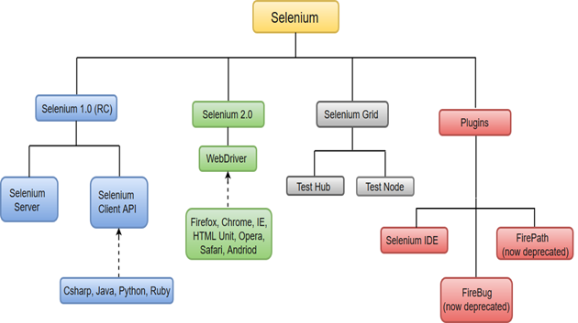

Selenium WebDriver performs much faster as compared to Selenium RC because it makes direct calls to the web browsers. RC on the other hand needs an RC server to interact with the browser.

WebDriver has a built-in implementation of Firefox driver (Gecko Driver). For other browsers, you need to plug-in their browser specific drivers to communicate and run the test. Most commonly used WebDriver's include:

* Google Chrome Driver
* Internet Explorer Driver
* Opera Driver
* Safari Driver

### **Browsers**

Browsers supported by Selenium WebDriver:

* Internet Explorer
* Mozilla Firefox
* Google Chrome
* Safari

## **Selenium WebDriver- Features**

Some of the most important features of Selenium WebDriver are:

* **Multiple Browser Support**: Selenium WebDriver supports a diverse range of web browsers such as Firefox, Chrome, Internet Explorer, Opera and many more. It also supports some of the non-conventional or rare browsers like HTMLUnit.

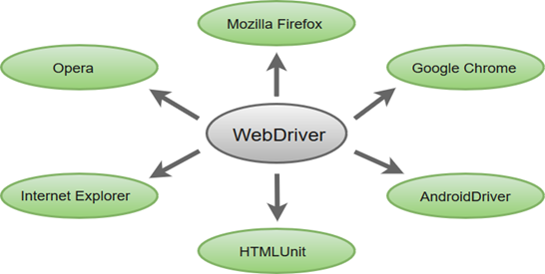

* **Multiple Languages Support**: WebDriver also supports most of the commonly used programming languages like Java, C#, JavaScript, PHP, Ruby, Pearl and Python. Thus, the user can choose any one of the supported programming language based on his/her competency and start building the test scripts.
* **Speed**: WebDriver performs faster as compared to other tools of Selenium Suite. Unlike RC, it doesn't require any intermediate server to communicate with the browser; rather the tool directly communicates with the browser.

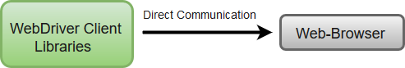

* **Simple Commands**: Most of the commands used in Selenium WebDriver are easy to implement. For instance, to launch a browser in WebDriver following commands are used:  
  **WebDriver driver** = **new FirefoxDriver();** (Firefox browser )  
  **WebDriver driver** = **new ChromeDriver();** (Chrome browser)  
  **WebDriver driver** = **new InternetExplorerDriver();** (Internet Explorer browser)
* **WebDriver- Methods and Classes**: WebDriver provides multiple solutions to cope with some potential challenges in automation testing.  
  WebDriver also allows testers to deal with complex types of web elements such as checkboxes, dropdowns and alerts through dynamic finders.

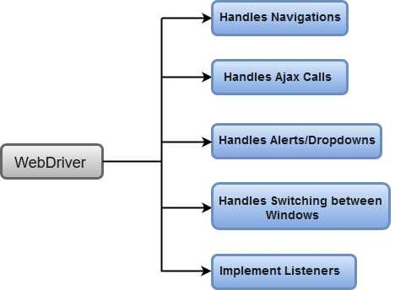

**How to Download & Install Selenium WebDriver**

**Selenium Architecture**

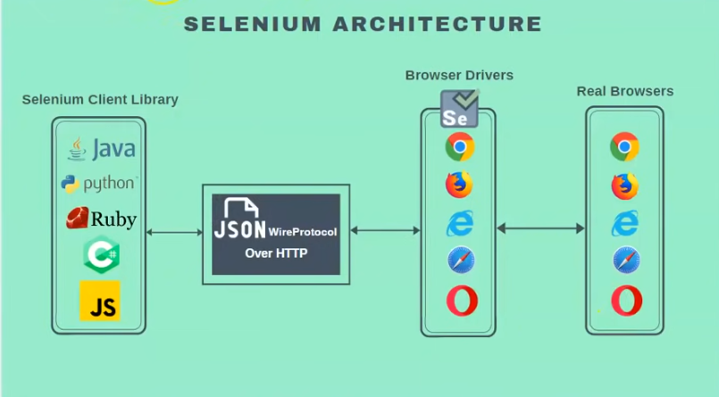

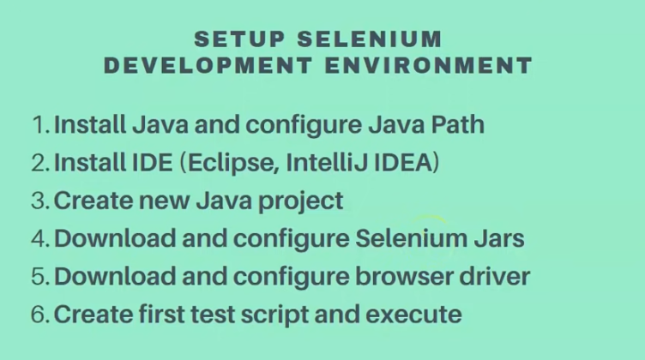

Selenium installation is a 3 step process:

1. Install Java SDK
2. Install Eclipse
3. Install Selenium Webdriver Files

## Step 1: Install JDK /Java

## Step 2 – Install Eclipse IDE

Download latest version of **“Eclipse IDE for Java Developers”** [here](https://www.eclipse.org/downloads/). Be sure to choose correctly between Windows 32 Bit and 64 Bit versions.

## Step 3 – Download the Selenium Java Client Driver

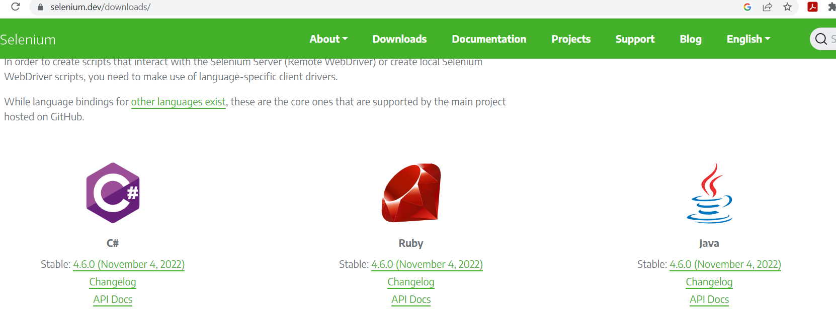

## Step 4 – Configure Eclipse IDE with WebDriver

Open Eclipse

1. Create a new project through File > New > Java Project. Name the project as “newproject”.
2. 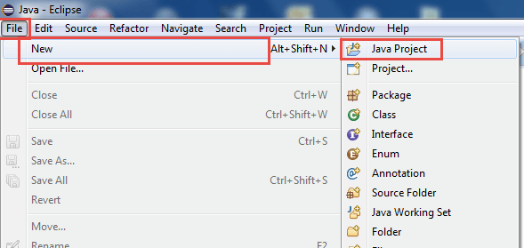

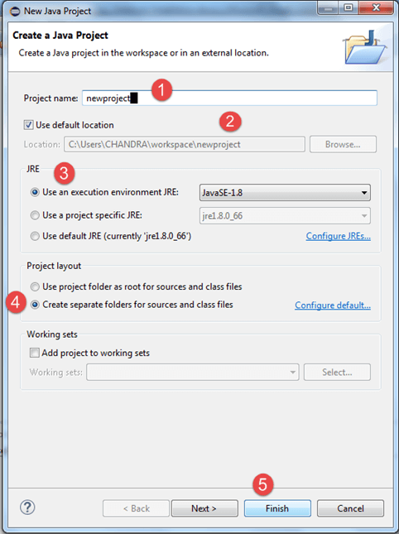

 In this step,

1. Right-click on the newly created project and
2. Select New > Package, and name that package as “newpackage”.

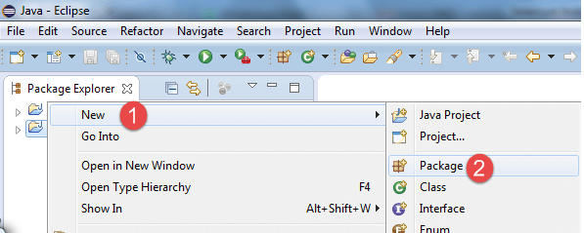

A pop-up window will open to name the package,

1. Enter the name of the package
2. Click on Finish button

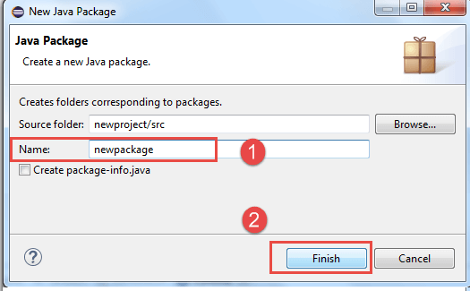

5. Create a new Java class under newpackage by right-clicking on it and then selecting- New > Class, and then name it as “MyClass”. Your Eclipse IDE should look like the image below.

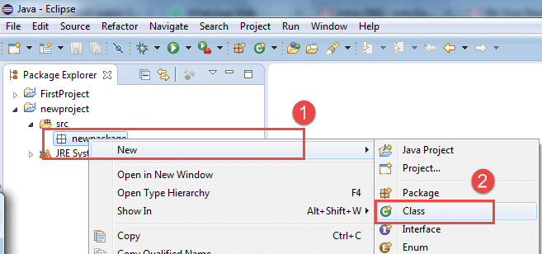

When you click on Class, a pop-up window will open, enter details as

1. Name of the class
2. Click on Finish button

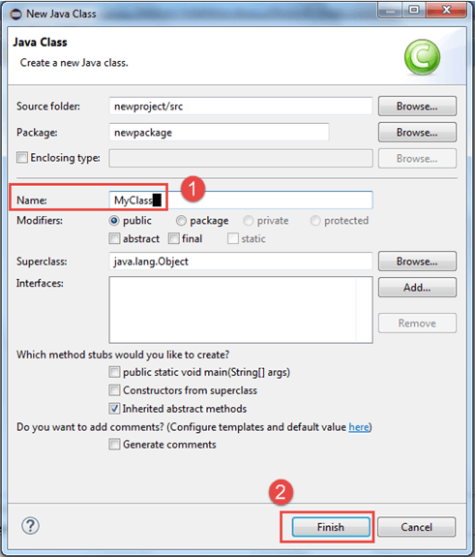

This is how it looks like after creating class.

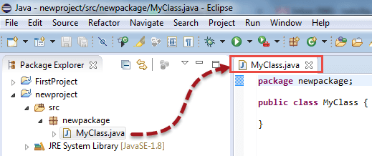

Now selenium WebDriver’s into Java Build Path

In this step,

1. Right-click on “newproject” and select **Properties**.
2. On the Properties dialog, click on “Java Build Path”.
3. Click on the **Libraries** tab, and then
4. Click on “Add External JARs..”

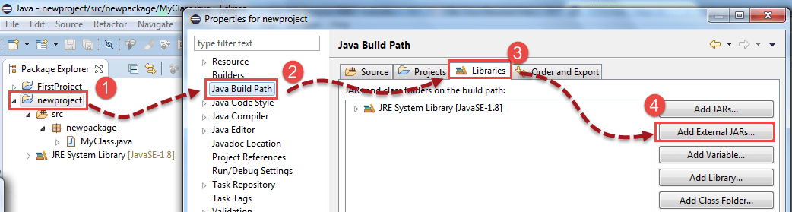

When you click on “Add External JARs..” It will open a pop-up window. Select the JAR files you want to add.

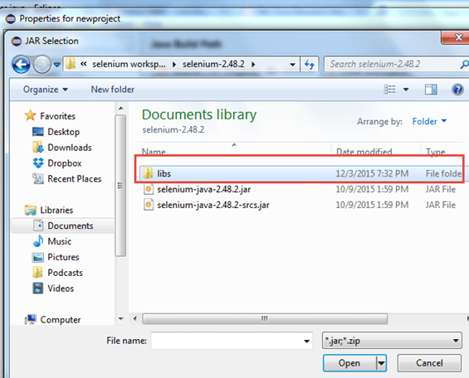

After selecting jar files, click on OK button.

Select all files inside the lib folder.

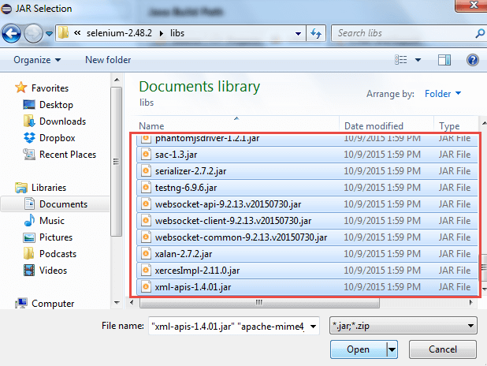

Select files outside lib folder

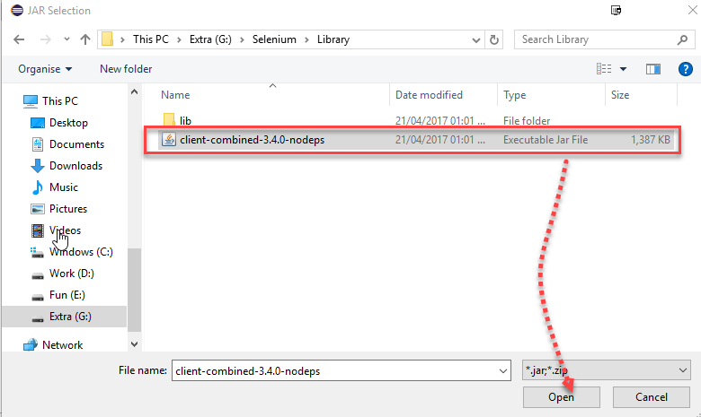

Once done, click “Apply and Close” button

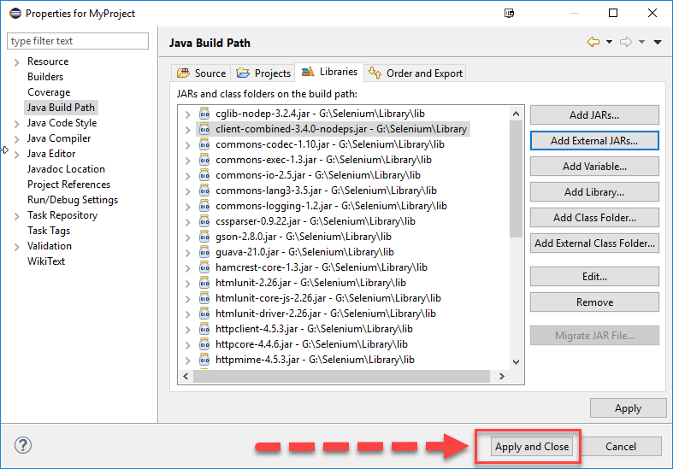

6. Add all the JAR files inside and outside the “libs” folder. Your Properties dialog should now look similar to the image below.

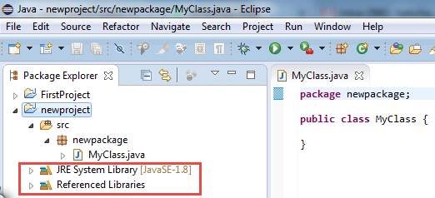

7. Finally, click OK and we are done importing Selenium libraries into our project.

### Different Drivers

**HTMLUnit and Firefox are two browsers that WebDriver can directly automate** – meaning that no other separate component is needed to install or run while the test is being executed. For other browsers, a separate program is needed. That program is called as the **Driver Server**.

A driver server is different for each browser. For example, Internet Explorer has its own driver server which you cannot use on other browsers. Below is the list of driver servers and the corresponding browsers that use them.

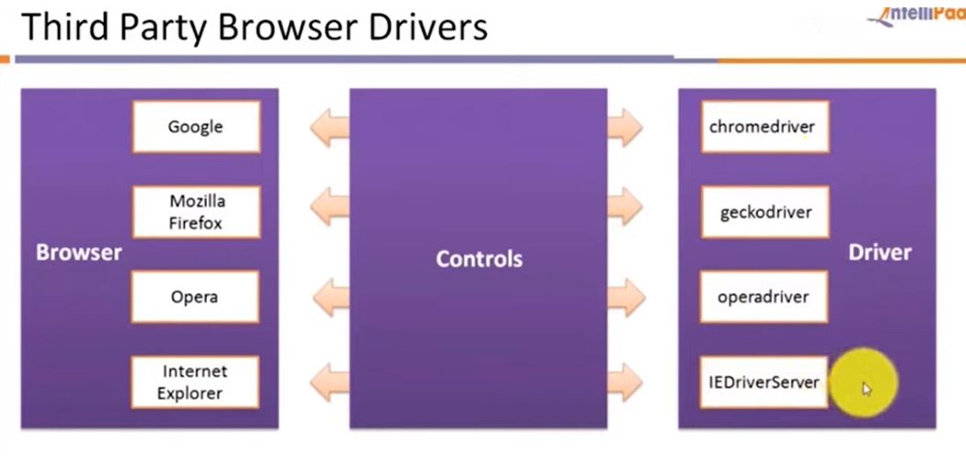

For chrome = chromedriver

<https://chromedriver.chromium.org/>

<https://chromedriver.storage.googleapis.com/index.html?path=108.0.5359.22/>

Firefox= geckodriver

<https://github.com/mozilla/geckodriver/releases>

Opera = opera driver

Internetexplorer = IEDriverserver

# First Selenium Webdriver Script: JAVA Sample Code Example

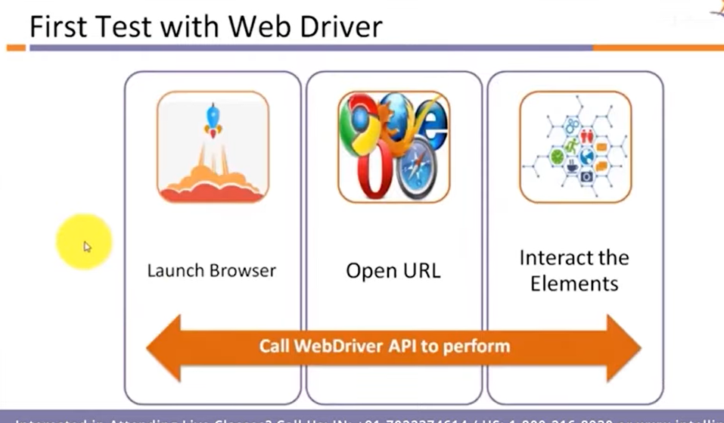

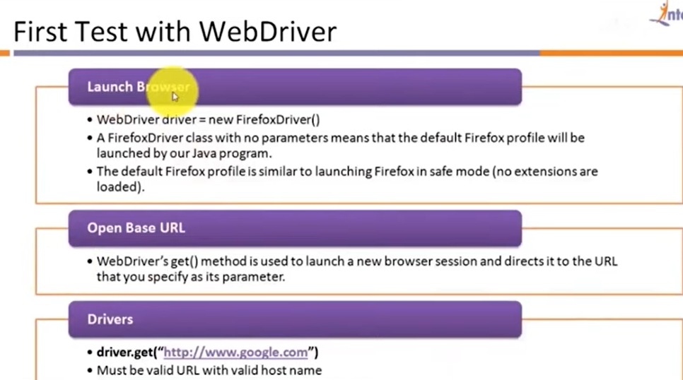

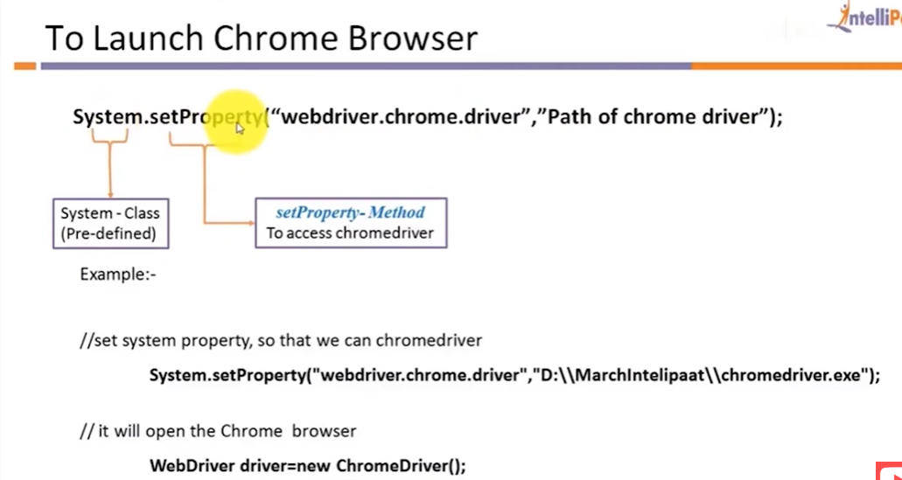

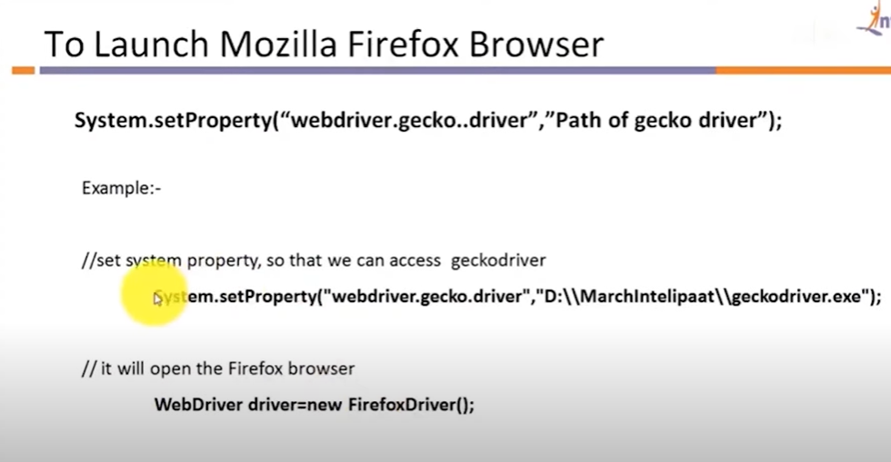

## Importing Packages

To get started, you need to import following two packages:

1. **org.openqa.selenium.\***– contains the WebDriver class needed to instantiate a new browser loaded with a specific driver
2. **org.openqa.selenium.firefox.FirefoxDriver**– contains the FirefoxDriver class needed to instantiate a Firefox-specific driver onto the browser instantiated by the WebDriver class

If your test needs more complicated actions such as accessing another class, taking browser screenshots, or manipulating external files, definitely you will need to import more packages.

## Instantiating objects and variables

Normally, this is how a driver object is instantiated.



A FirefoxDriver class with no parameters means that the default Firefox profile will be launched by our Java program. The default Firefox profile is similar to launching Firefox in safe mode (no extensions are loaded).

For convenience, we saved the Base URL and the expected title as variables.

Here Package Name is : WebDriver_Basic

Class name: WebDriver1

**package** WebDriver_Basic;

**import** org.openqa.selenium.WebDriver;

**import** org.openqa.selenium.chrome.ChromeDriver;

**public** **class** WebDriver1 {

**public** **static** **void** main(String[] args) {

// **TODO** Auto-generated method stub

System.*setProperty*("Webdriver.chrome.driver","E:\\Academics\\STQA\\2022\\selenium\\Practical\\Driver\\chromedriver.exe");

WebDriver driver = **new** ChromeDriver();

driver.get("https://www.google.com/");

}

}

**Then run this program and see the new web page has been opened with Google.com**

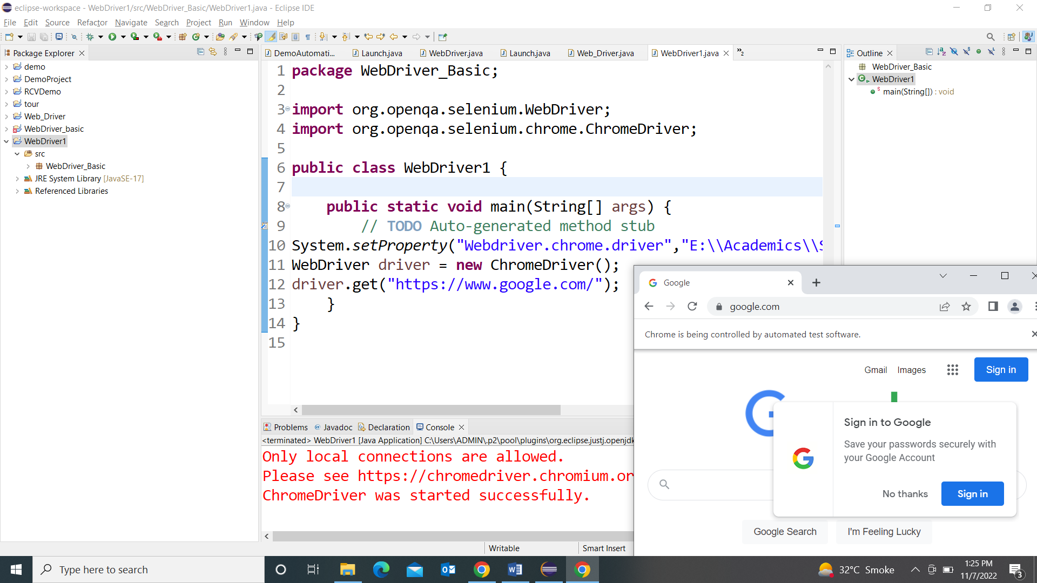

**Program 2:**

**package** WebDriver_Basic;

**import** org.openqa.selenium.WebDriver;

**import** org.openqa.selenium.chrome.ChromeDriver;

**public** **class** WebDriver1 {

**public** **static** **void** main(String[] args) {

// **TODO** Auto-generated method stub

System.*setProperty*("Webdriver.chrome.driver","E:\\Academics\\STQA\\2022\\selenium\\Practical\\Driver\\chromedriver.exe");

WebDriver driver = **new** ChromeDriver();

driver.get("https://www.google.com/");

String title = driver.getTitle();

System.***out***.println("title is" +title);

}

}

**Output:**

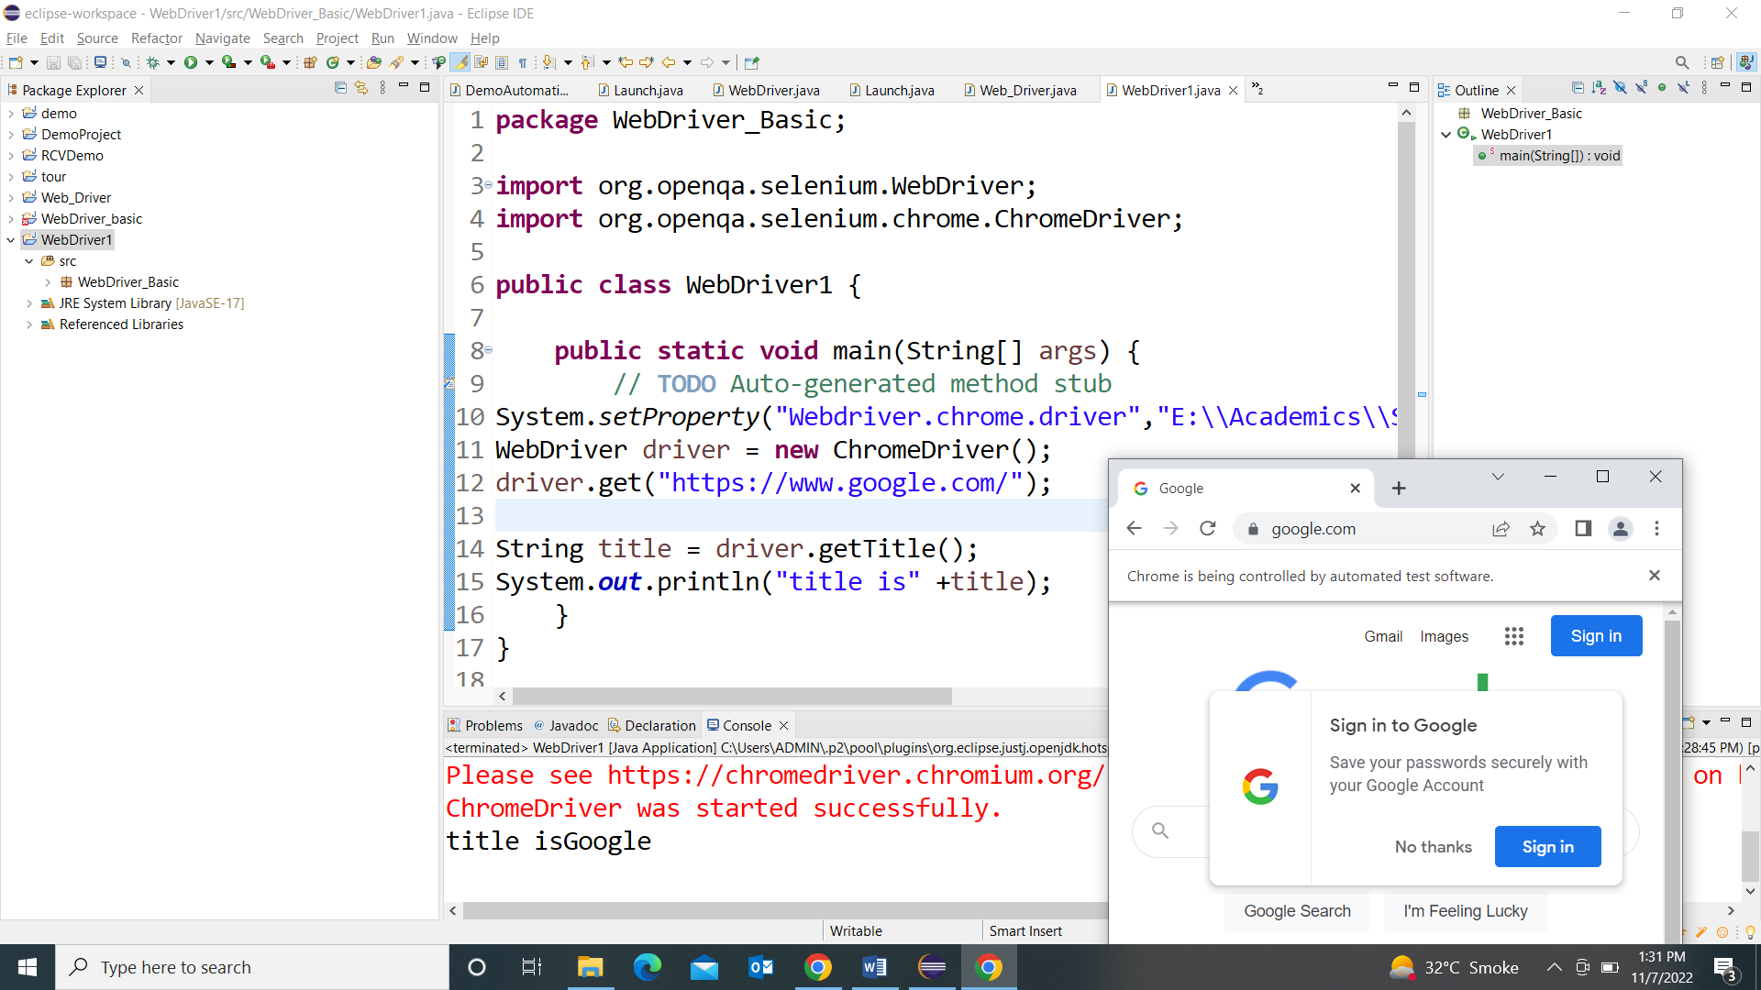

**Programme 3:**

**Firefox Driver :**

**package** WebDriver_Basic;

**import** org.openqa.selenium.WebDriver;

//import org.openqa.selenium.chrome.ChromeDriver;

**import** org.openqa.selenium.firefox.FirefoxDriver;

**public** **class** firefoxdriver {

**public** **static** **void** main(String[] args) {

// **TODO** Auto-generated method stub

System.*setProperty*("Webdriver.gecko.driver","E:\\Academics\\STQA\\2022\\selenium\\Practical\\Driver\\geckodriver.exe");

WebDriver driver = **new** FirefoxDriver();

driver.get("https://www.google.com/");

}

}

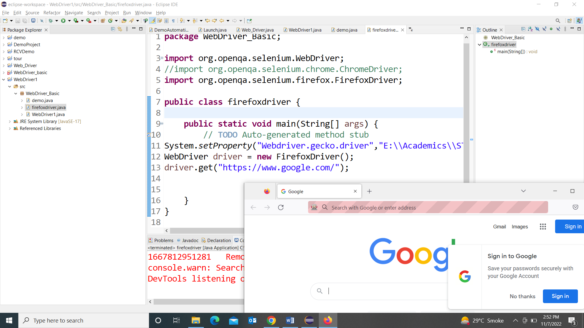

**Web Elements**

**Open any website and show the elements by right click🡺 inspect🡺 and it will highlight the elements**

**Facebook New registration page:**

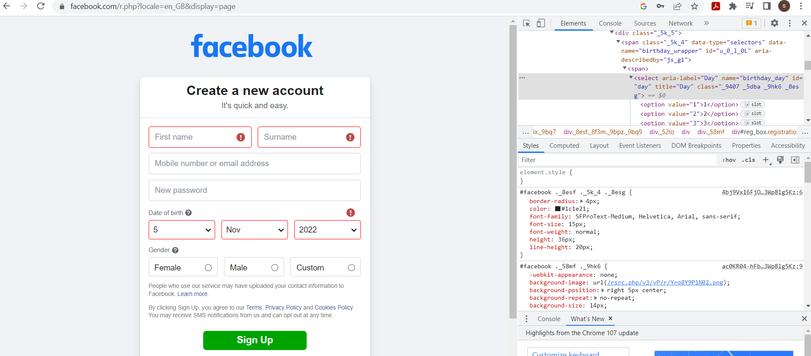

**Packages:**

**.By** Mechanism used to locate elements within a document.

**.webdriver** WebDriver is a remote control interface that enables introspection and control of user agents (browsers).

**.webelement** represents an HTML element.

**Elements**

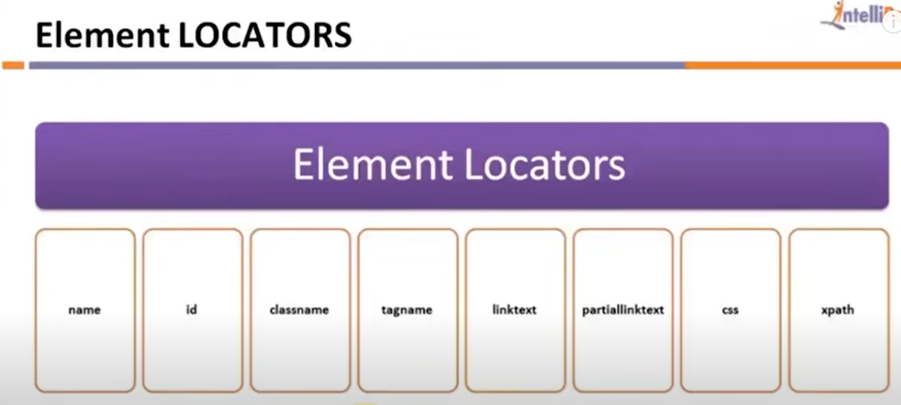

A list of Locating Strategies used in WebDriver:

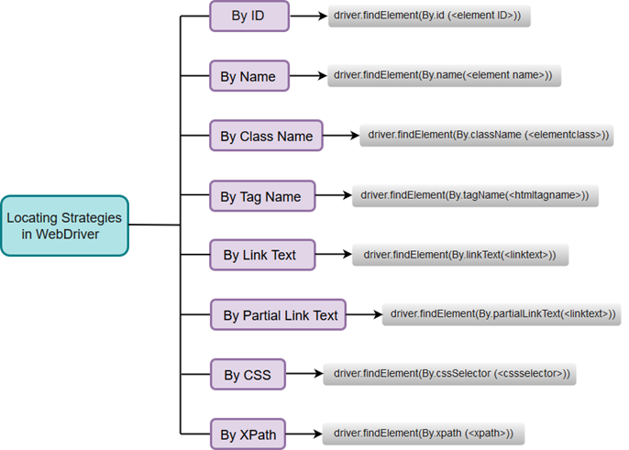

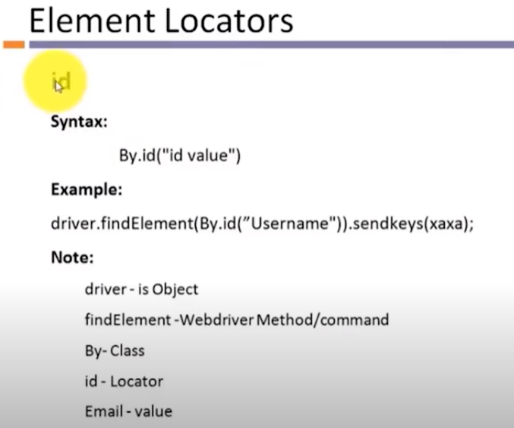

**Programme : find element by _id**

**package** WebDriver_Basic;

**import** org.openqa.selenium.By;

**import** org.openqa.selenium.WebDriver;

**import** org.openqa.selenium.WebElement;

**import** org.openqa.selenium.chrome.ChromeDriver;

**public** **class** findelement {

**public** **static** **void** main(String[] args) {

// **TODO** Auto-generated method stub

System.*setProperty*("Webdriver.chrome.driver","E:\\Academics\\STQA\\2022\\selenium\\Practical\\Driver\\chromedriver.exe");

WebDriver driver = **new** ChromeDriver();

driver.get("https://www.facebook.com/");

WebElement unm=driver.findElement(By.*id*("email"));

unm.sendKeys("swap@gmail.com");

}

}

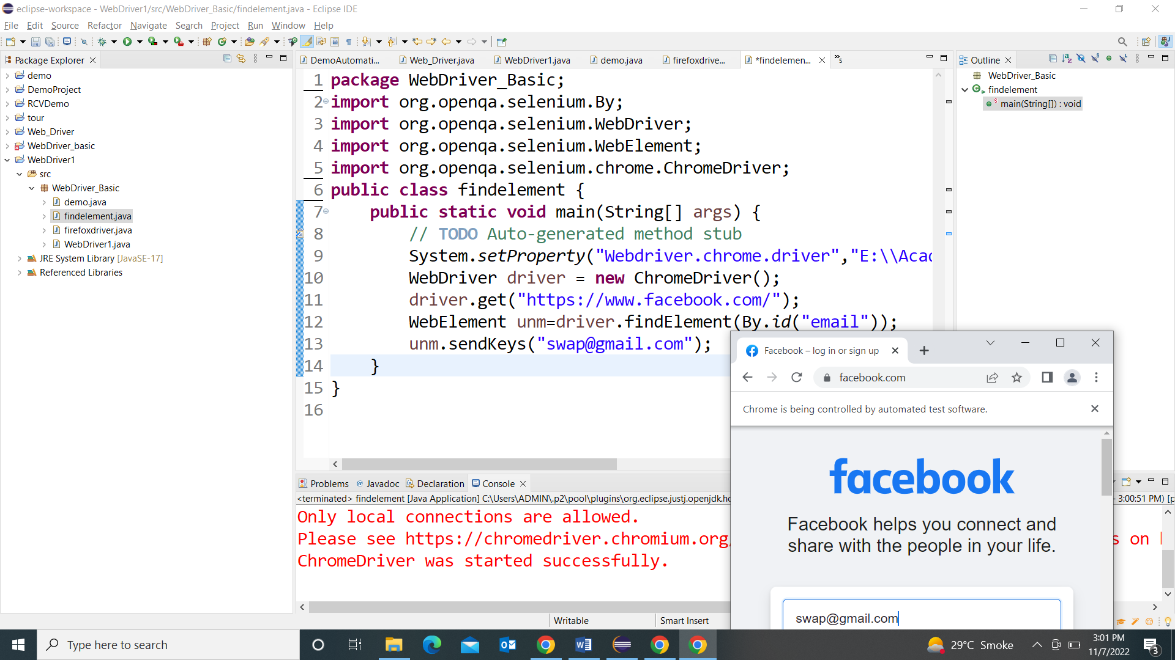

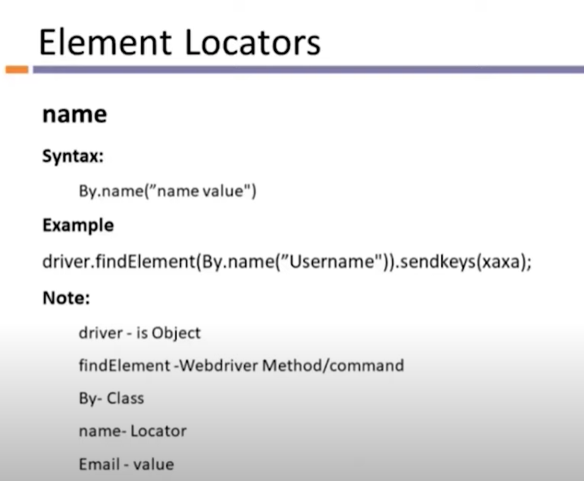

**Programme : findelement by id and name**

**Login and password and button**

**package WebDriver_Basic;**

**import org.openqa.selenium.By;**

**import org.openqa.selenium.WebDriver;**

**import org.openqa.selenium.WebElement;**

**import org.openqa.selenium.chrome.ChromeDriver;**

**public class findelement1 {**

**public static void main(String[] args) {**

**// TODO Auto-generated method stub**

**System.setProperty("Webdriver.chrome.driver","E:\\Academics\\STQA\\2022\\selenium\\Practical\\Driver\\chromedriver.exe");**

**WebDriver driver = new ChromeDriver();**

**driver.get("https://www.facebook.com/");**

**WebElement unm=driver.findElement(By.id("email"));**

**unm.sendKeys("swap@gmail.com");**

**WebElement unm2=driver.findElement(By.name("pass"));**

**unm2.sendKeys("123");**

**WebElement button=driver.findElement(By.name("login"));**

**button.click();**

**}**

**}**

**It will automatically open the facebook login**

**Automatically enter the values in the login and password , auto click on login button also .**

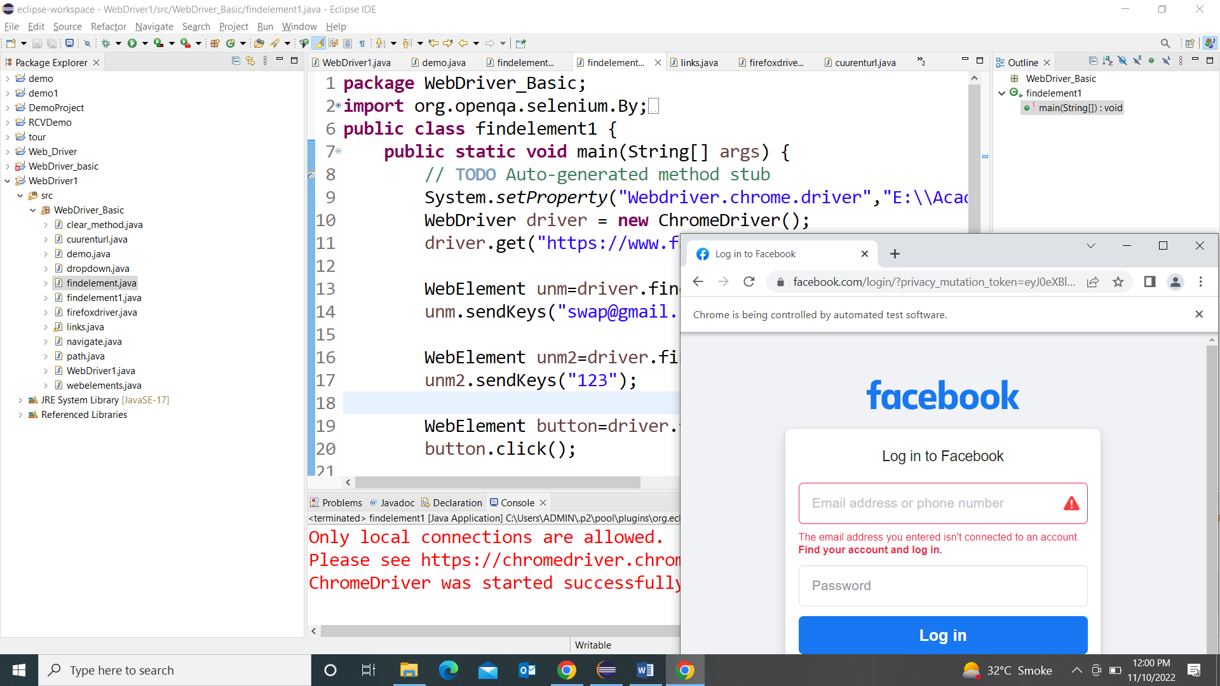

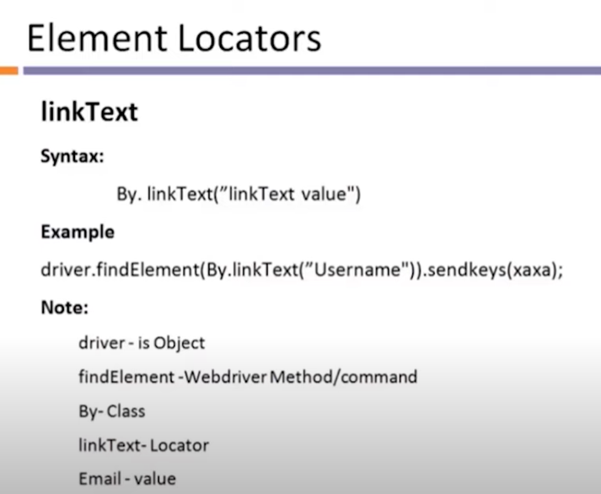

**How to inspect Links:**

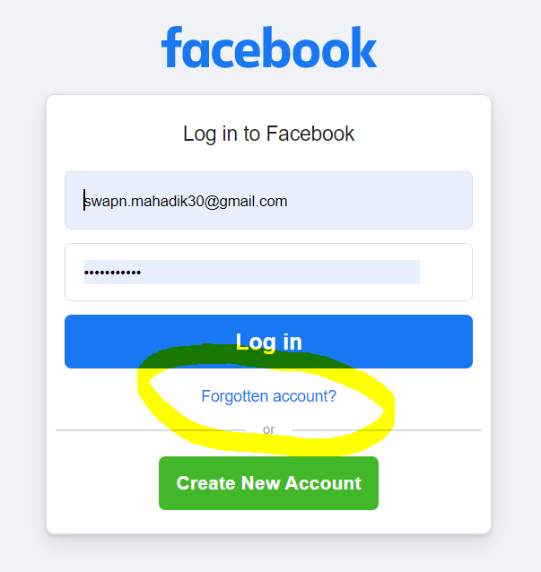

**Just like : Forgotten account**

**package** WebDriver_Basic;

**import** org.openqa.selenium.By;

**import** org.openqa.selenium.WebDriver;

**import** org.openqa.selenium.WebElement;

**import** org.openqa.selenium.chrome.ChromeDriver;

**public** **class** links {

**public** **static** **void** main(String[] args) {

// **TODO** Auto-generated method stub

System.*setProperty*("Webdriver.chrome.driver","E:\\Academics\\STQA\\2022\\selenium\\Practical\\Driver\\chromedriver.exe");

WebDriver driver = **new** ChromeDriver();

driver.get("https://www.facebook.com/");

driver.findElement(By.*linkText*("Forgotten password?")).click();

//driver.close();

//driver.quit();

}

}

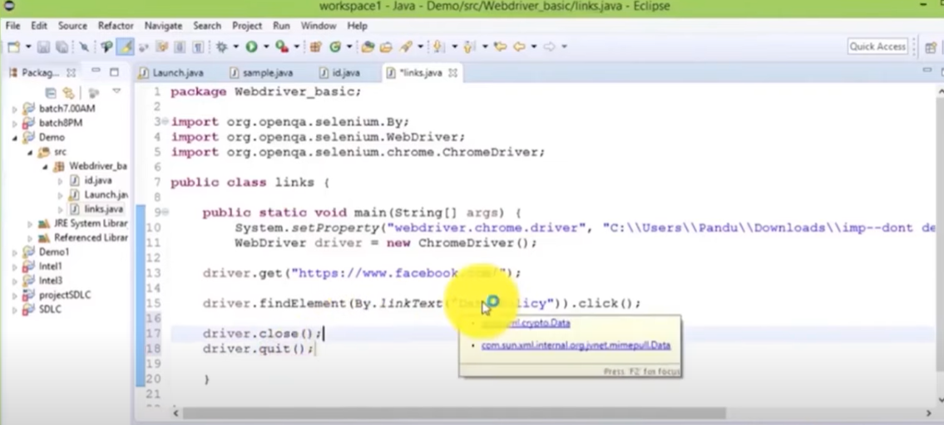

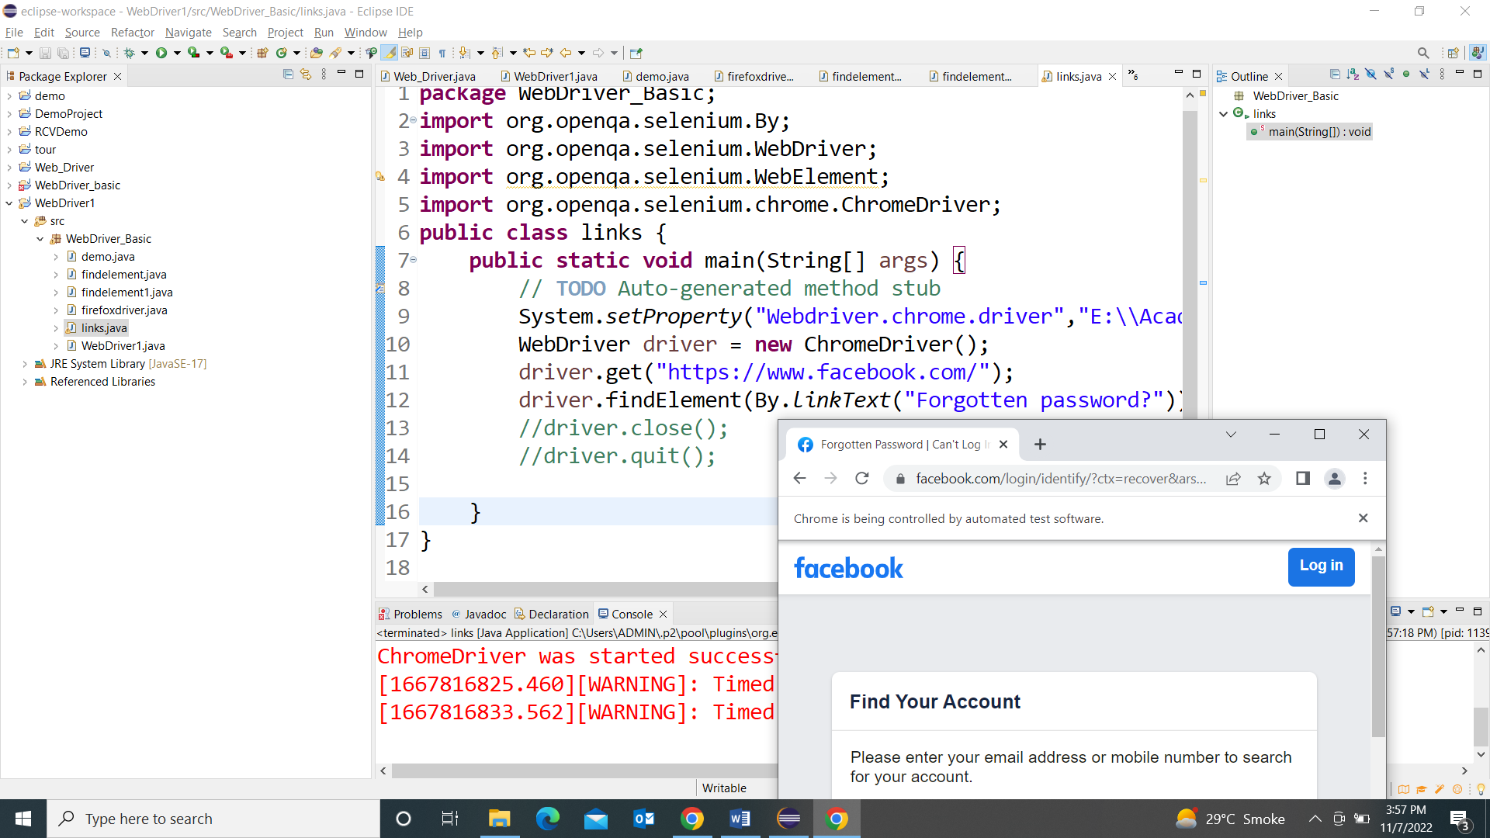

**Firebug and Firepath**

**For older version only**

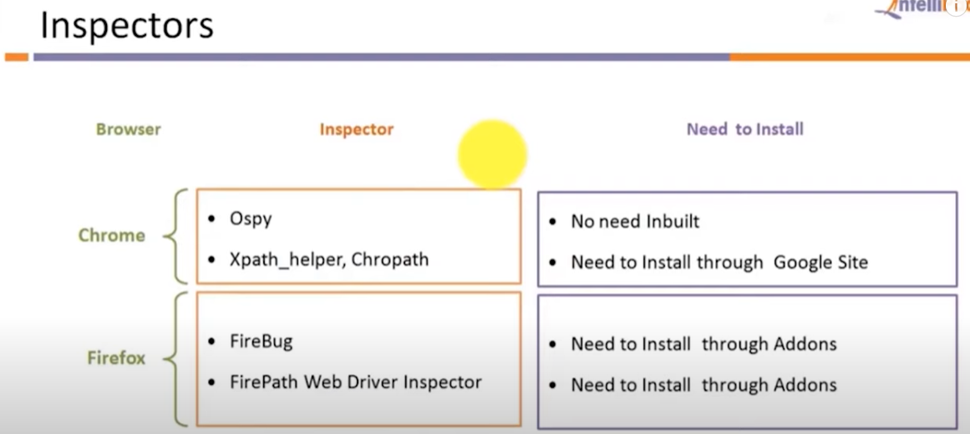

**For new versions ..no firebug**

**Alternate option is inspect**

**Web Drivers Method**

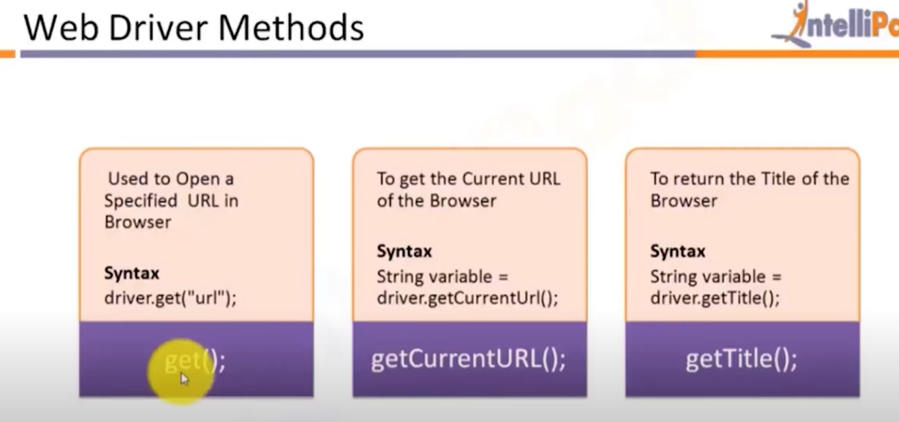

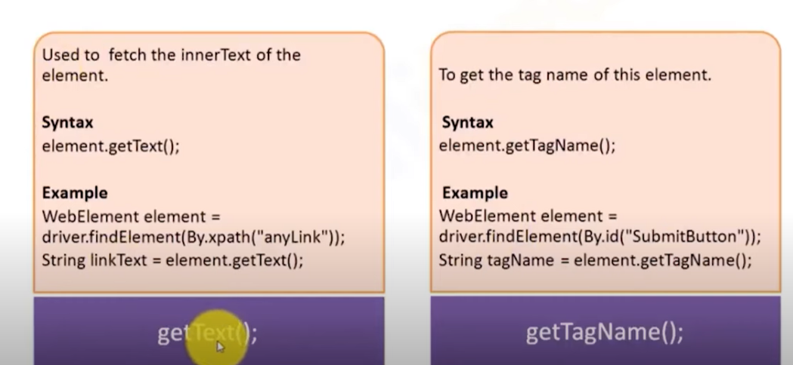

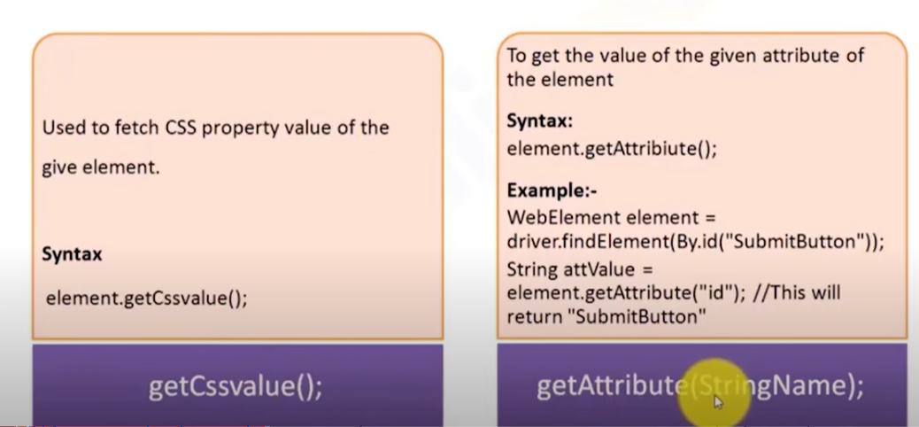

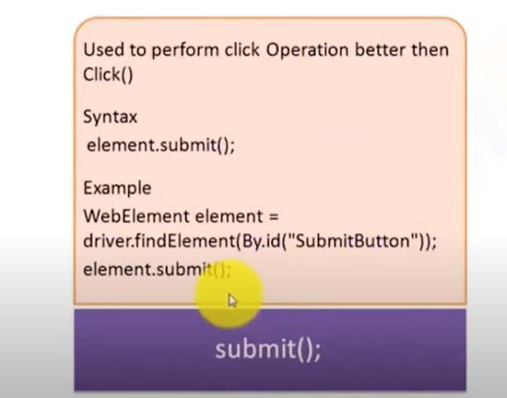

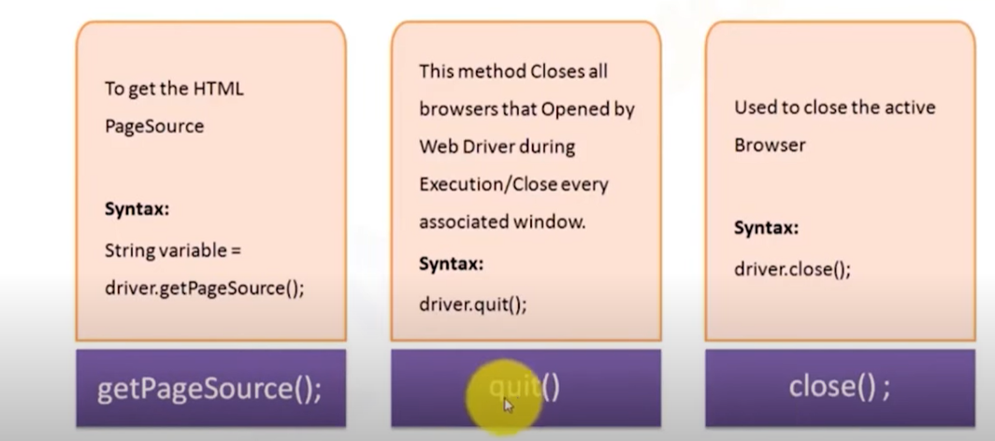

**Create a new class with a main method**

**package** webdriver_basic;

**import** org.openqa.selenium.By;

**import** org.openqa.selenium.WebDriver;

**import** org.openqa.selenium.WebElement;

**import** org.openqa.selenium.chrome.ChromeDriver;

**public** **class** webelements {

**public** **static** **void** main(String[] args) {

// **TODO** Auto-generated method stub

System.*setProperty*("webdriver.chrome.driver","E:\\Academics\\STQA\\2022\\selenium\\driver\\chromedriver.exe");

WebDriver driver=**new** ChromeDriver();

driver.get("https://www.facebook.com/login/");

string title = driver.getTitle();

System.***out***.println("Title is", + title);

}

}

**This program will get title of mentioned web page and print it as output in consol**

**Alternate way is : just replace**

**This code** string title = driver.getTitle();

System.***out***.println("Title is", + title);

**With this**

System.***out***.println("driver”.getcurrenturl());

Programm:

**package** WebDriver_Basic;

**import** org.openqa.selenium.WebDriver;

**import** org.openqa.selenium.chrome.ChromeDriver;

**public** **class** cuurenturl {

**public** **static** **void** main(String[] args) {

// **TODO** Auto-generated method stub

System.*setProperty*("Webdriver.chrome.driver","E:\\Academics\\STQA\\2022\\selenium\\Practical\\Driver\\chromedriver.exe");

WebDriver driver = **new** ChromeDriver();

driver.get("https://www.google.com/");

//String title = driver.getTitle();

//System.out.println("title is" +title);

System.***out***.println(driver.getCurrentUrl());

}

}

**And run the program**

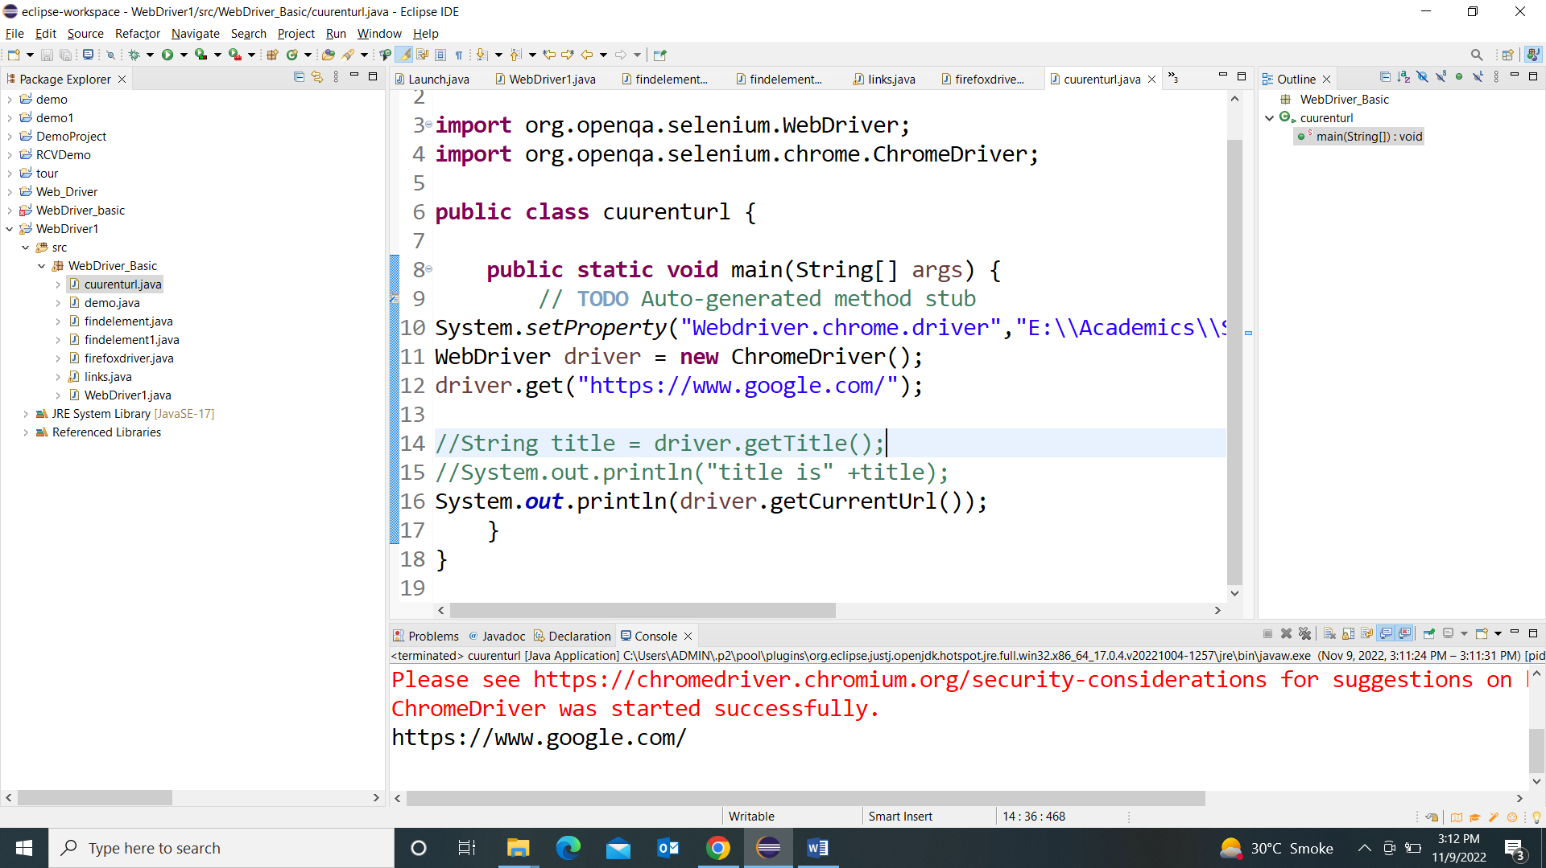

**package** webdriver_basic;

**import** org.openqa.selenium.By;

**import** org.openqa.selenium.WebDriver;

**import** org.openqa.selenium.WebElement;

**import** org.openqa.selenium.chrome.ChromeDriver;

**public** **class** webelements {

**public** **static** **void** main(String[] args) {

// **TODO** Auto-generated method stub

System.*setProperty*("webdriver.chrome.driver","E:\\Academics\\STQA\\2022\\selenium\\driver\\chromedriver.exe");

WebDriver driver=**new** ChromeDriver();

driver.get("https://www.facebook.com/login/");

string title = driver.getTitle();

System.***out***.println("Title is", + title);

//===================================================

System.***out***.println("driver",getCurrentUrl());

WebElement unm= driver.findelement(By.id("email"));

System.***out***.println(unm.getAttribute("id"));

System.***out***.println(unm.getTagName); //Html tag name is ID

}

}

**Output : op will display : attribute is email**

**And Tag as Input**

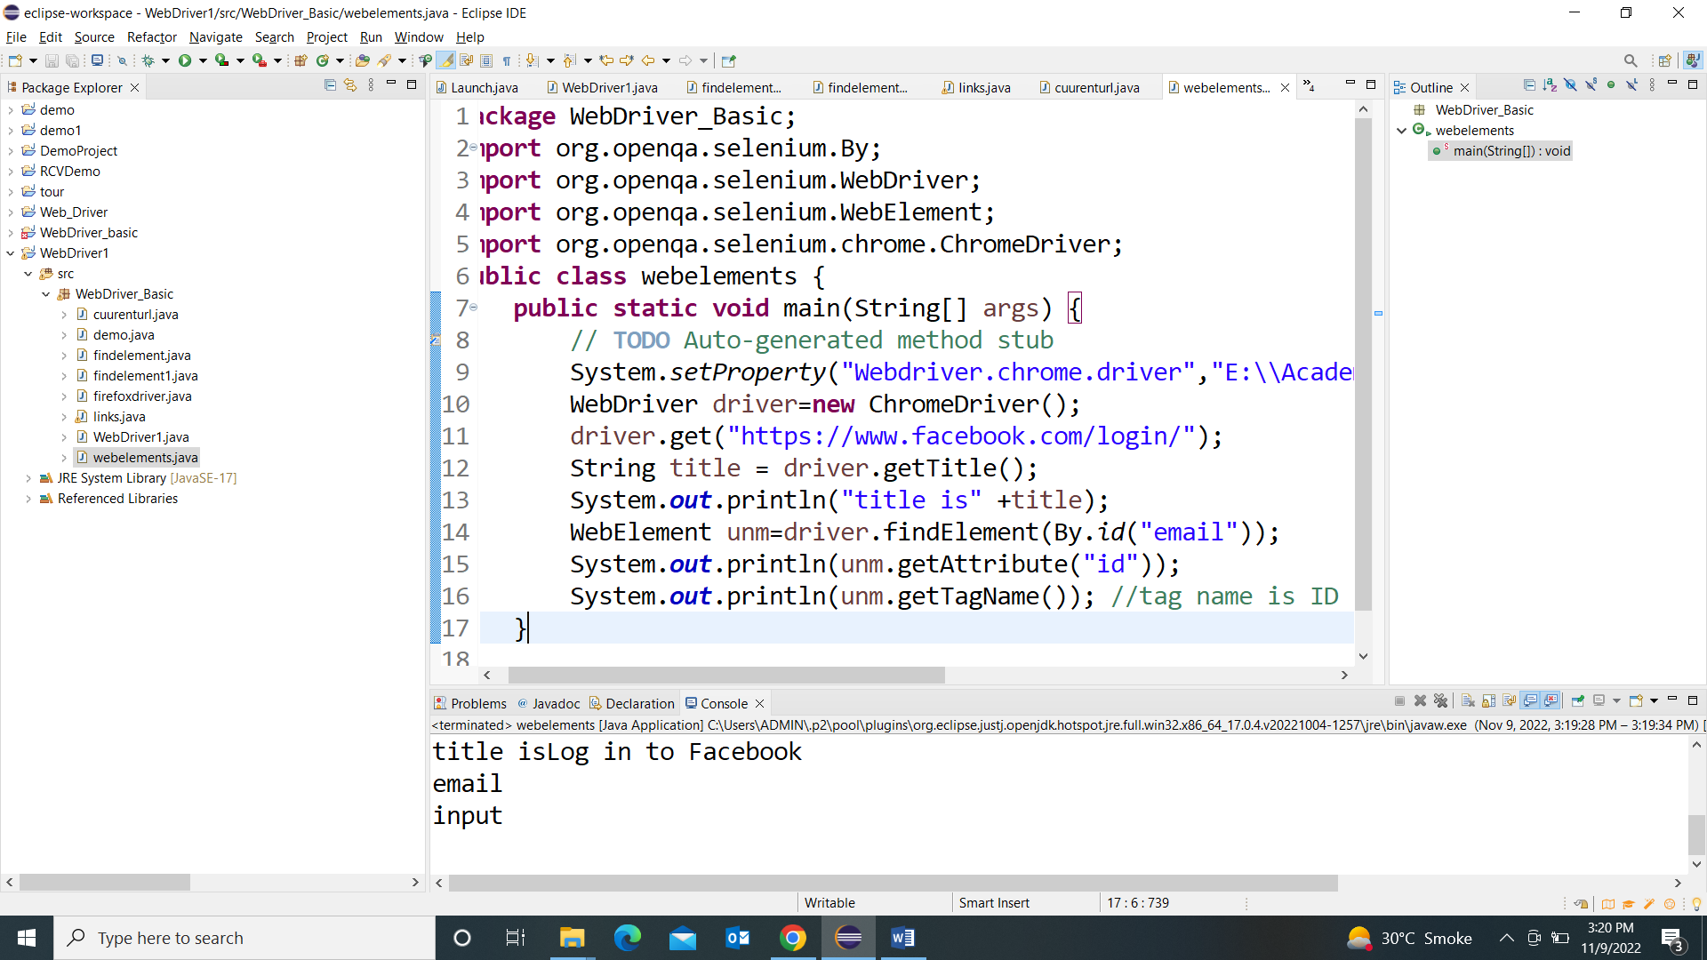

**Browser Navigation method : Video : 1.52.52 minutes onwards**

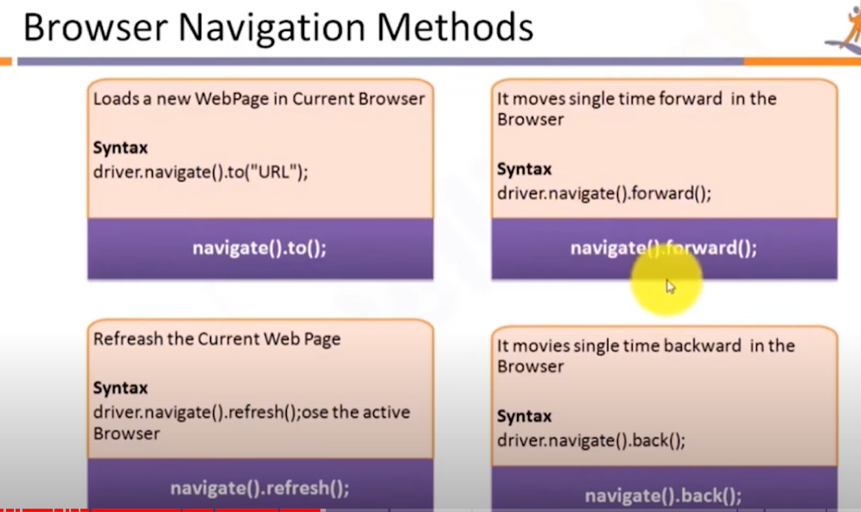

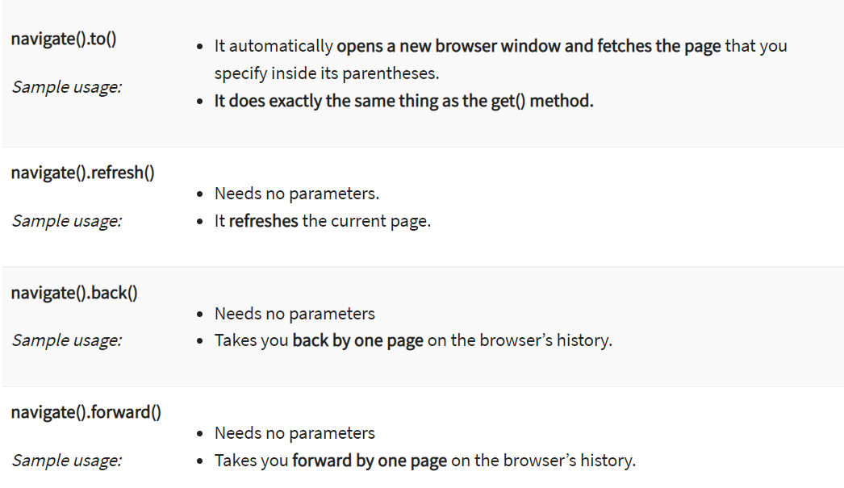

These commands allow you to  refresh,go-into and switch back and forth between different web pages

**Because we cant inspect back buttons of browser**

**So let us start with program**

Create a new class **navigate**

**package** WebDriver_Basic;

**import** org.openqa.selenium.By;

**import** org.openqa.selenium.WebDriver;

**import** org.openqa.selenium.chrome.ChromeDriver;

**public** **class** navigate {

**public** **static** **void** main(String[] args) **throws** InterruptedException {

// **TODO** Auto-generated method stub

System.*setProperty*("Webdriver.chrome.driver","E:\\Academics\\STQA\\2022\\selenium\\driver\\chromedriver.exe");

WebDriver driver = **new** ChromeDriver();

//driver.get("https://www.google.com");

driver.navigate().to("https://www.google.com");

driver.findElement(By.*linkText*("Images")).click();

Thread.*sleep*(2000);

driver.navigate().back();

Thread.*sleep*(1000);

System.***out***.println("back done........");

driver.navigate().forward();

Thread.*sleep*(1000);

System.***out***.println("Forward done........");

driver.navigate().refresh();

Thread.*sleep*(1000);

System.***out***.println("refresh done........");

}

}

**Output :After running this code: it will open google.com in browser first auto click on image link and the back and then forward and refresh.**

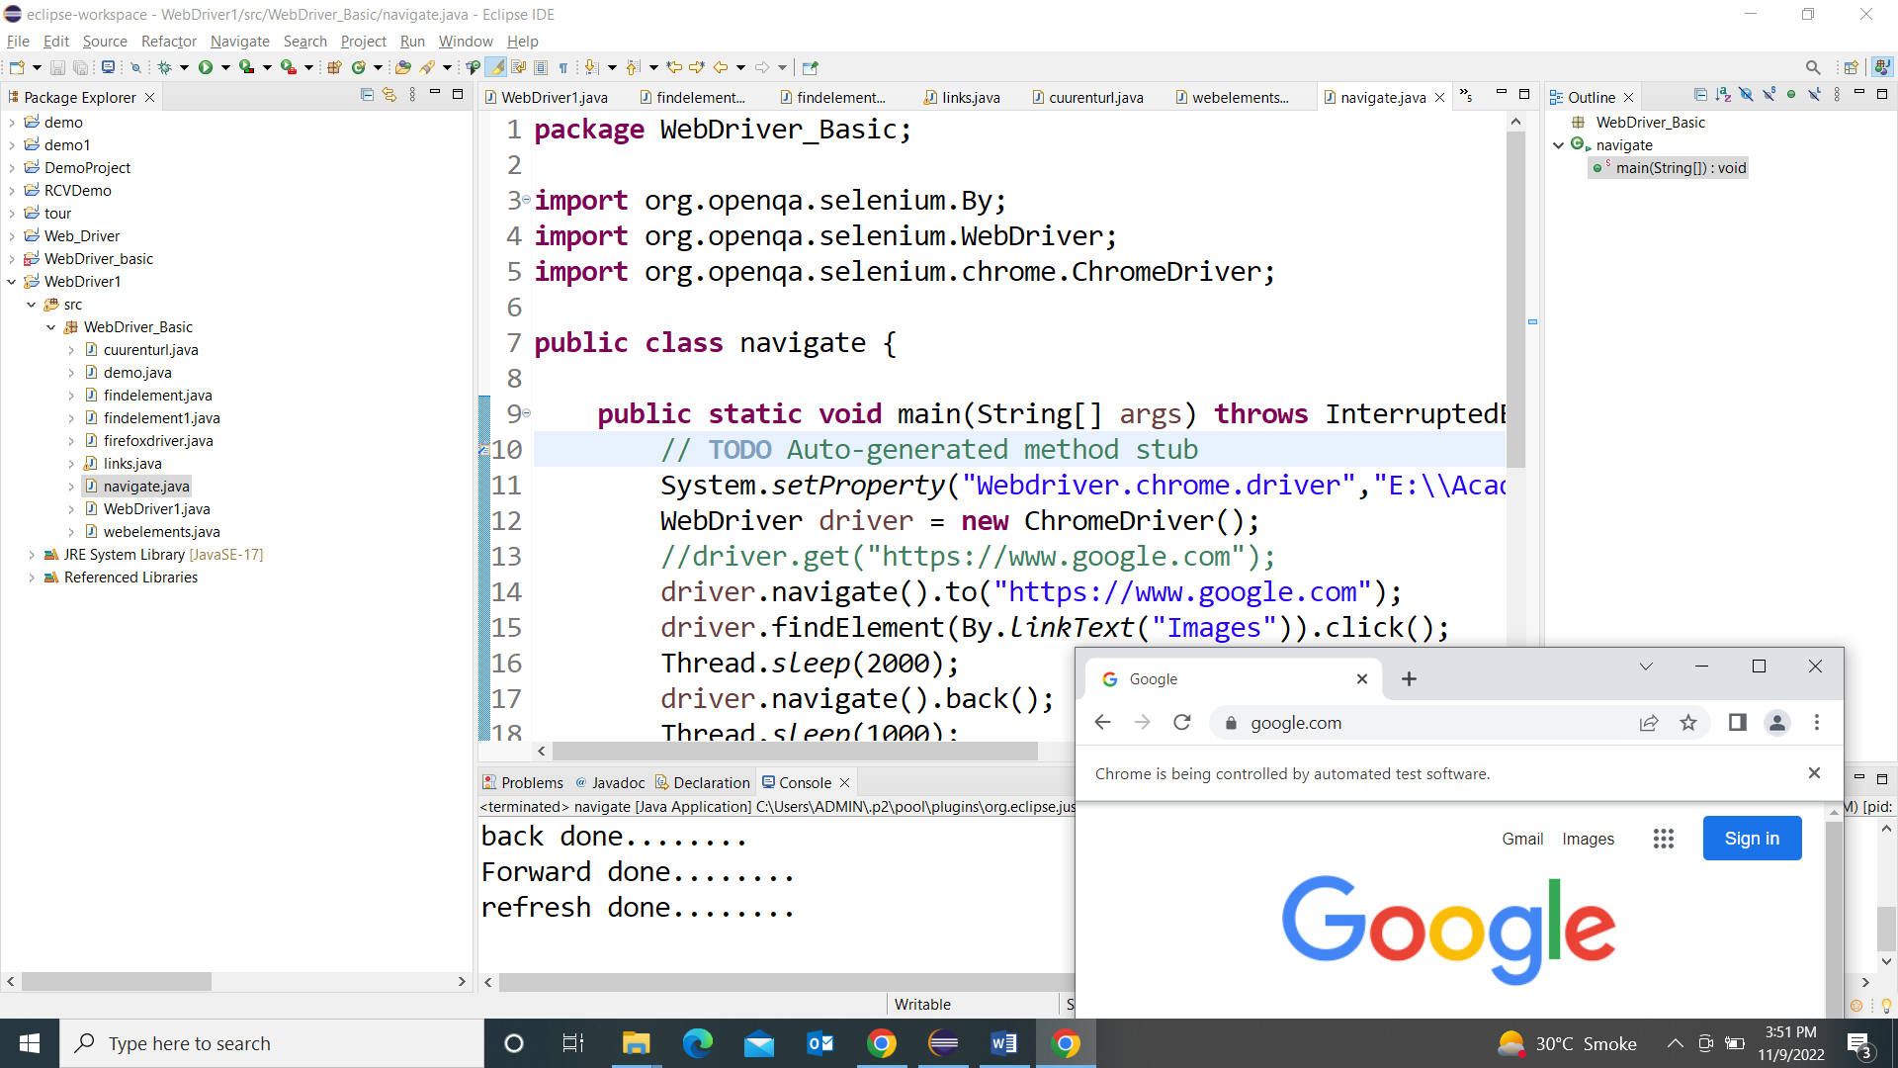

**Find element by Xpath**

**Program for Xpath:**

XPath is a language to query XML documents. Usable on both HTML and XML documents, it allows testers to navigate through the XML structure of any document. It consists of a path expression along with some conditions.

#### Syntax of XPath

Below is the syntax for Xpath:

Xpath =//tagname[@Attribute=’value’]

Wherein:

1. **//**: Used to select the current node.
2. **tagname**: Name of the tag of a particular node.
3. **@:** Used to select the select attribute.
4. **Attribute:** Name of the attribute of the node.
5. **Value**: Value of the attribute

Example 1:

**package** newproject1;

**import** org.openqa.selenium.By;

**import** org.openqa.selenium.WebDriver;

**import** org.openqa.selenium.WebElement;

**import** org.openqa.selenium.chrome.ChromeDriver;

**public** **class** path {

**public** **static** **void** main(String[] args) {

// **TODO** Auto-generated method stub

System.*setProperty*("Webdriver.chrome.driver","E:\\Academics\\STQA\\2022\\selenium\\driver\\chromedriver.exe");

WebDriver driver = **new** ChromeDriver();

driver.get("https://login.yahoo.com/account/create");

driver.findElement(By.*xpath*("//input[@id='usernamereg-firstName']")).sendKeys("Swapnali");

// Will send values to First Name tab

}

}

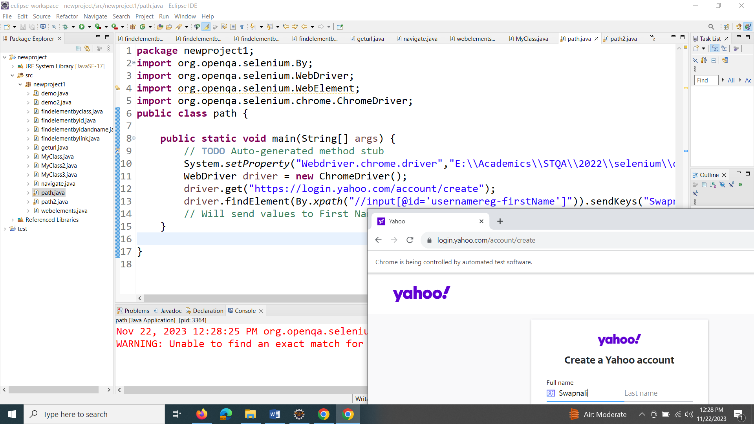

Example 2:

**package** newproject1;

**import** org.openqa.selenium.By;

**import** org.openqa.selenium.WebDriver;

**import** org.openqa.selenium.WebElement;

**import** org.openqa.selenium.chrome.ChromeDriver;

**public** **class** path2 {

**public** **static** **void** main(String[] args) {

// **TODO** Auto-generated method stub

System.*setProperty*("Webdriver.chrome.driver","E:\\Academics\\STQA\\2022\\selenium\\driver\\chromedriver.exe");

WebDriver driver = **new** ChromeDriver();

driver.get("https://login.yahoo.com/account/create");

driver.findElement(By.*xpath*("//input[@id='usernamereg-firstName']")).sendKeys("Swapnali");

// Will send values to First Name tab

driver.findElement(By.*xpath*("//input[@id='usernamereg-lastName']")).sendKeys("Mahadik"); //xpath for last name box

driver.findElement(By.*xpath*("//input[@id='usernamereg-userId']")).sendKeys("email@yahoo.com"); //xpath for email box

driver.findElement(By.*xpath*("//button[@id='reg-submit-button']")).click();// xpath for submit button

}

}

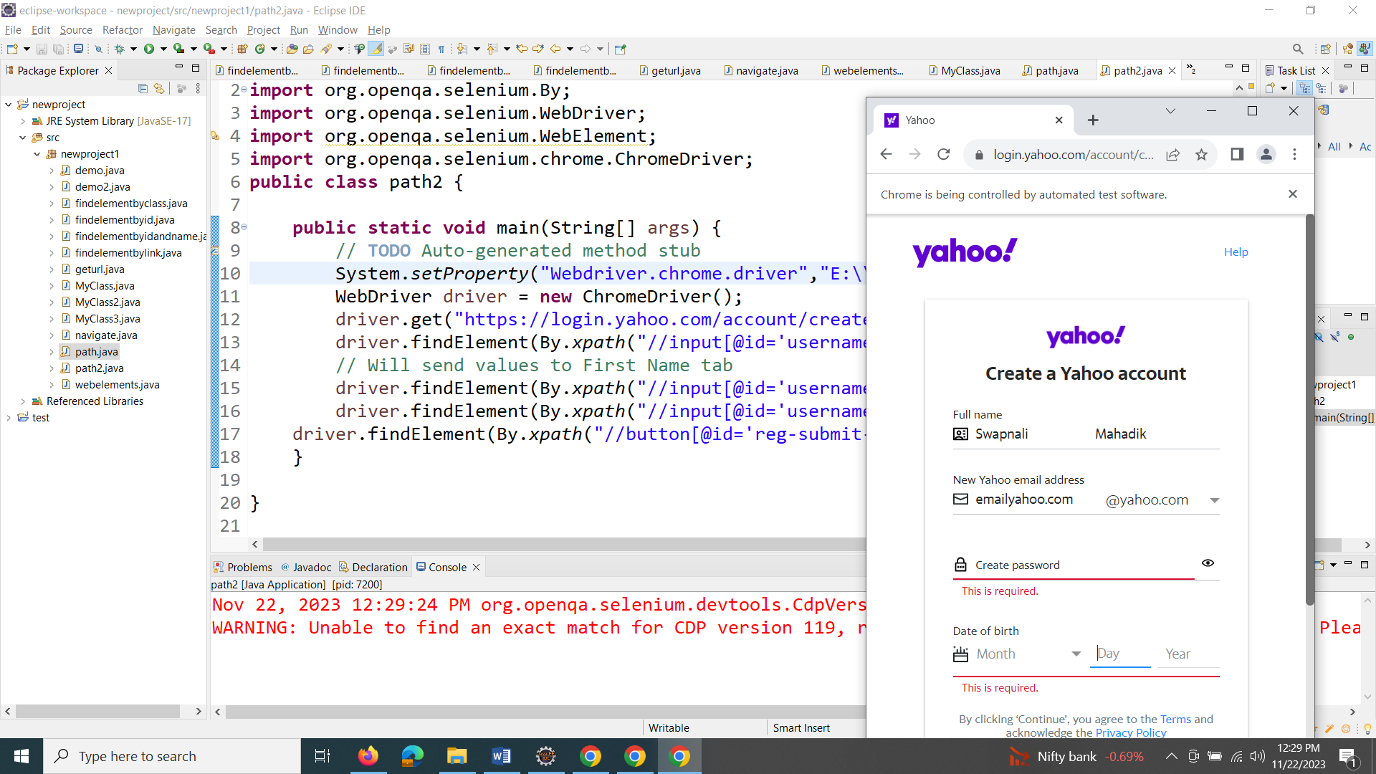

Web Element Methods

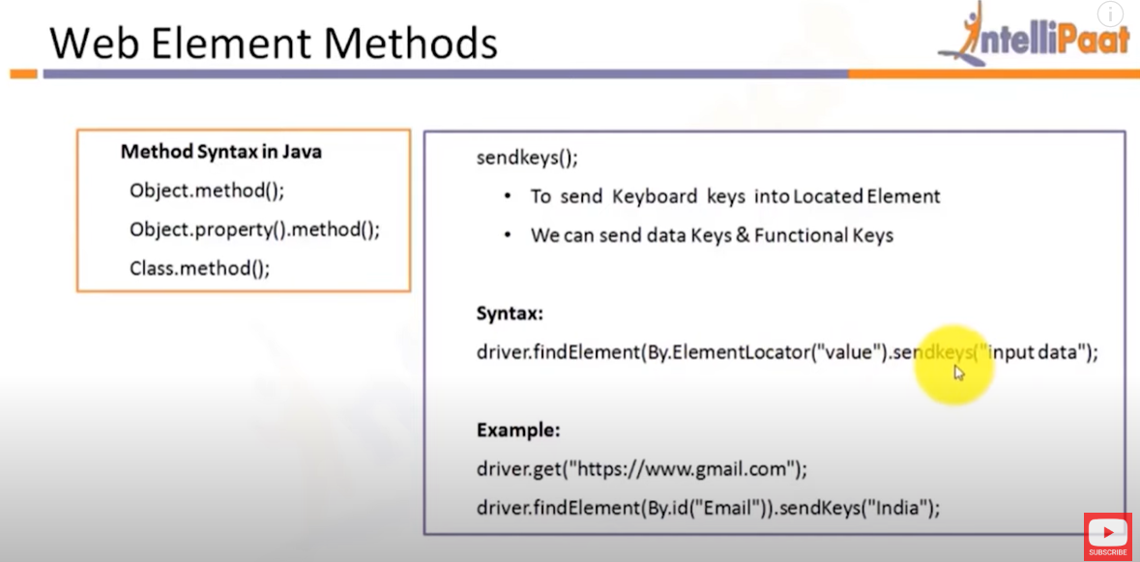

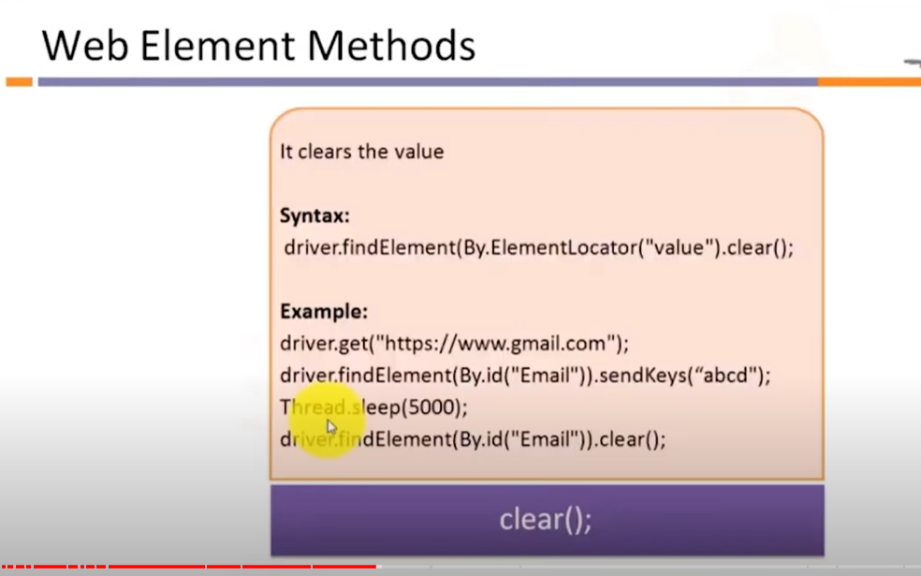

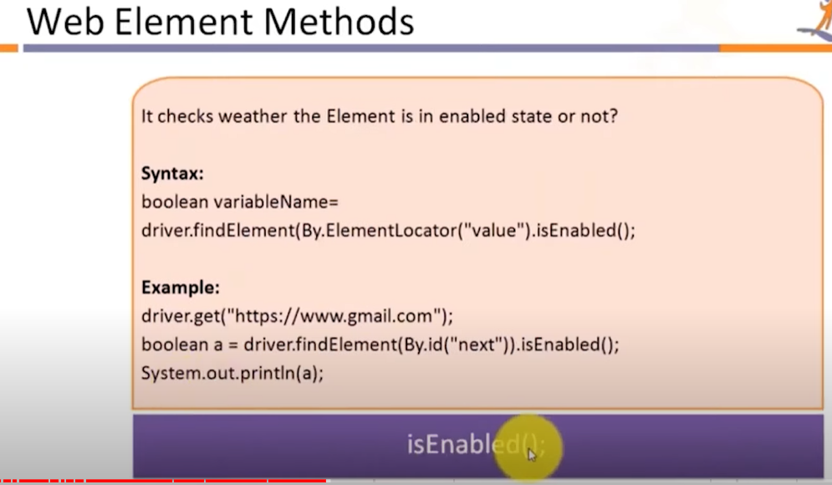

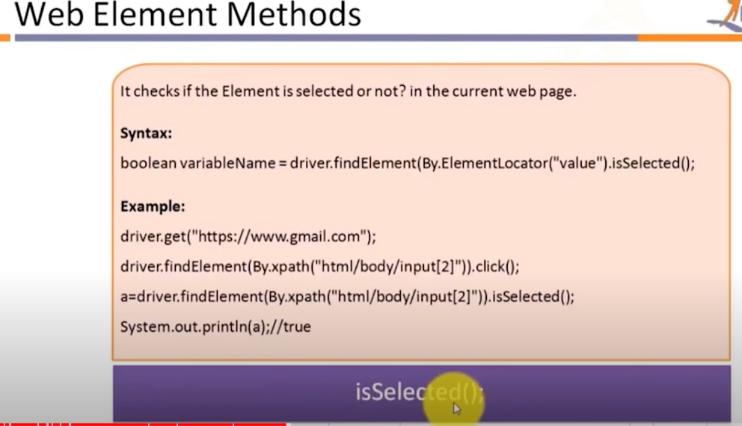

Example 3: Xpath with method

package WebDriver_Basic;

import org.openqa.selenium.By;

import org.openqa.selenium.WebDriver;

import org.openqa.selenium.WebElement;

import org.openqa.selenium.chrome.ChromeDriver;

public class path {

public static void main(String[] args) {

// TODO Auto-generated method stub

System.setProperty("Webdriver.chrome.driver","E:\\Academics\\STQA\\2022\\selenium\\driver\\chromedriver.exe");

WebDriver driver = new ChromeDriver();

driver.get("https://www.facebook.com/");

// This is a XPath : //*[@id="content"]/div/div/div/div[1]/div/img WebElement img = driver.findElement(By.xpath("//*[@id=\"content\"]/div/div/div/div[1]/div/img"));

System.out.println(img.isDisplayed());

System.out.println(img.isEnabled());

System.out.println(img.isSelected());

}

}

Output

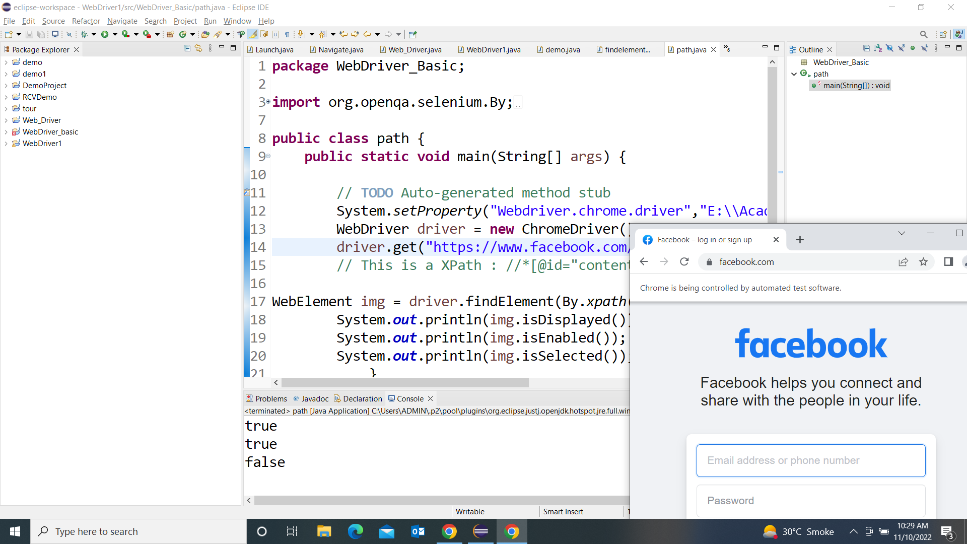

**Clear Method**

**package** WebDriver_Basic;

**import** org.openqa.selenium.By;

**import** org.openqa.selenium.WebDriver;

**import** org.openqa.selenium.WebElement;

**import** org.openqa.selenium.chrome.ChromeDriver;

**public** **class** clear_method{

**public** **static** **void** main(String[] args) **throws** InterruptedException {

// **TODO** Auto-generated method stub

System.*setProperty*("Webdriver.chrome.driver","E:\\Academics\\STQA\\2022\\selenium\\Practical\\Driver\\chromedriver.exe");

WebDriver driver = **new** ChromeDriver();

driver.get("https://www.facebook.com/");

WebElement unm = driver.findElement(By.*id*("email"));

unm.sendKeys("hi welcome");

Thread.*sleep*(2000); // to see the first entry on browser add sleep time

unm.clear();

unm.sendKeys("second text");

}}

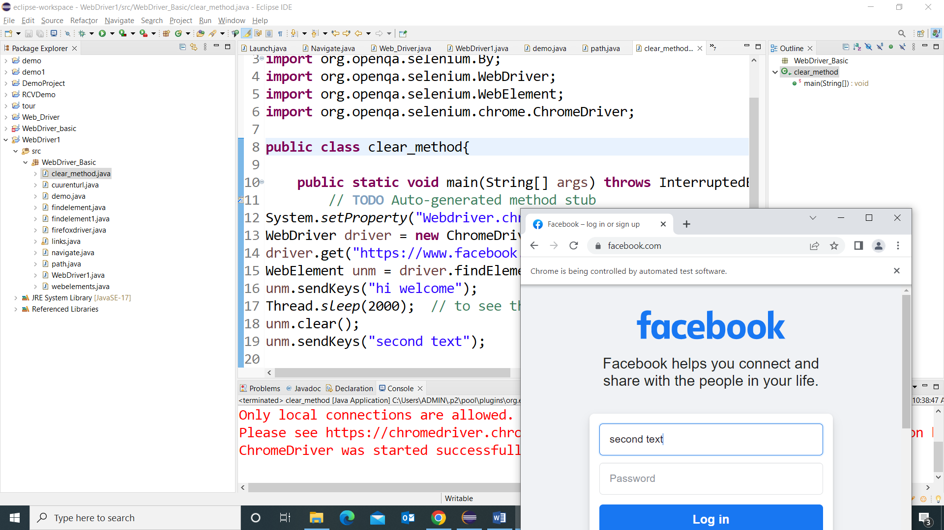

Dropdown:

## Select Class in Selenium

The **Select Class in Selenium** is a method used to implement the HTML SELECT tag. The html select tag provides helper methods to select and deselect the elements. The Select class is an ordinary class so New keyword is used to create its object and it specifies the web element location.

Programme: Drop Down : Video time 2.41.45 onwards

**package** WebDriver_Basic;

**import** org.openqa.selenium.By;

**import** org.openqa.selenium.WebDriver;

**import** org.openqa.selenium.chrome.ChromeDriver;

**import** org.openqa.selenium.support.ui.Select;

**public** **class** dropdown {

**public** **static** **void** main(String[] args) {

// **TODO** Auto-generated method stub

System.*setProperty*("Webdriver.chrome.driver","E:\\Academics\\STQA\\2022\\selenium\\Practical\\Driver\\chromedriver.exe");

WebDriver driver = **new** ChromeDriver();

driver.get("https://www.facebook.com/r.php?r=101");

Select month= **new** Select(driver.findElement(By.*id*("month")));

//month.deselectByVisibleText("Oct");

month.selectByIndex(2);

}

}

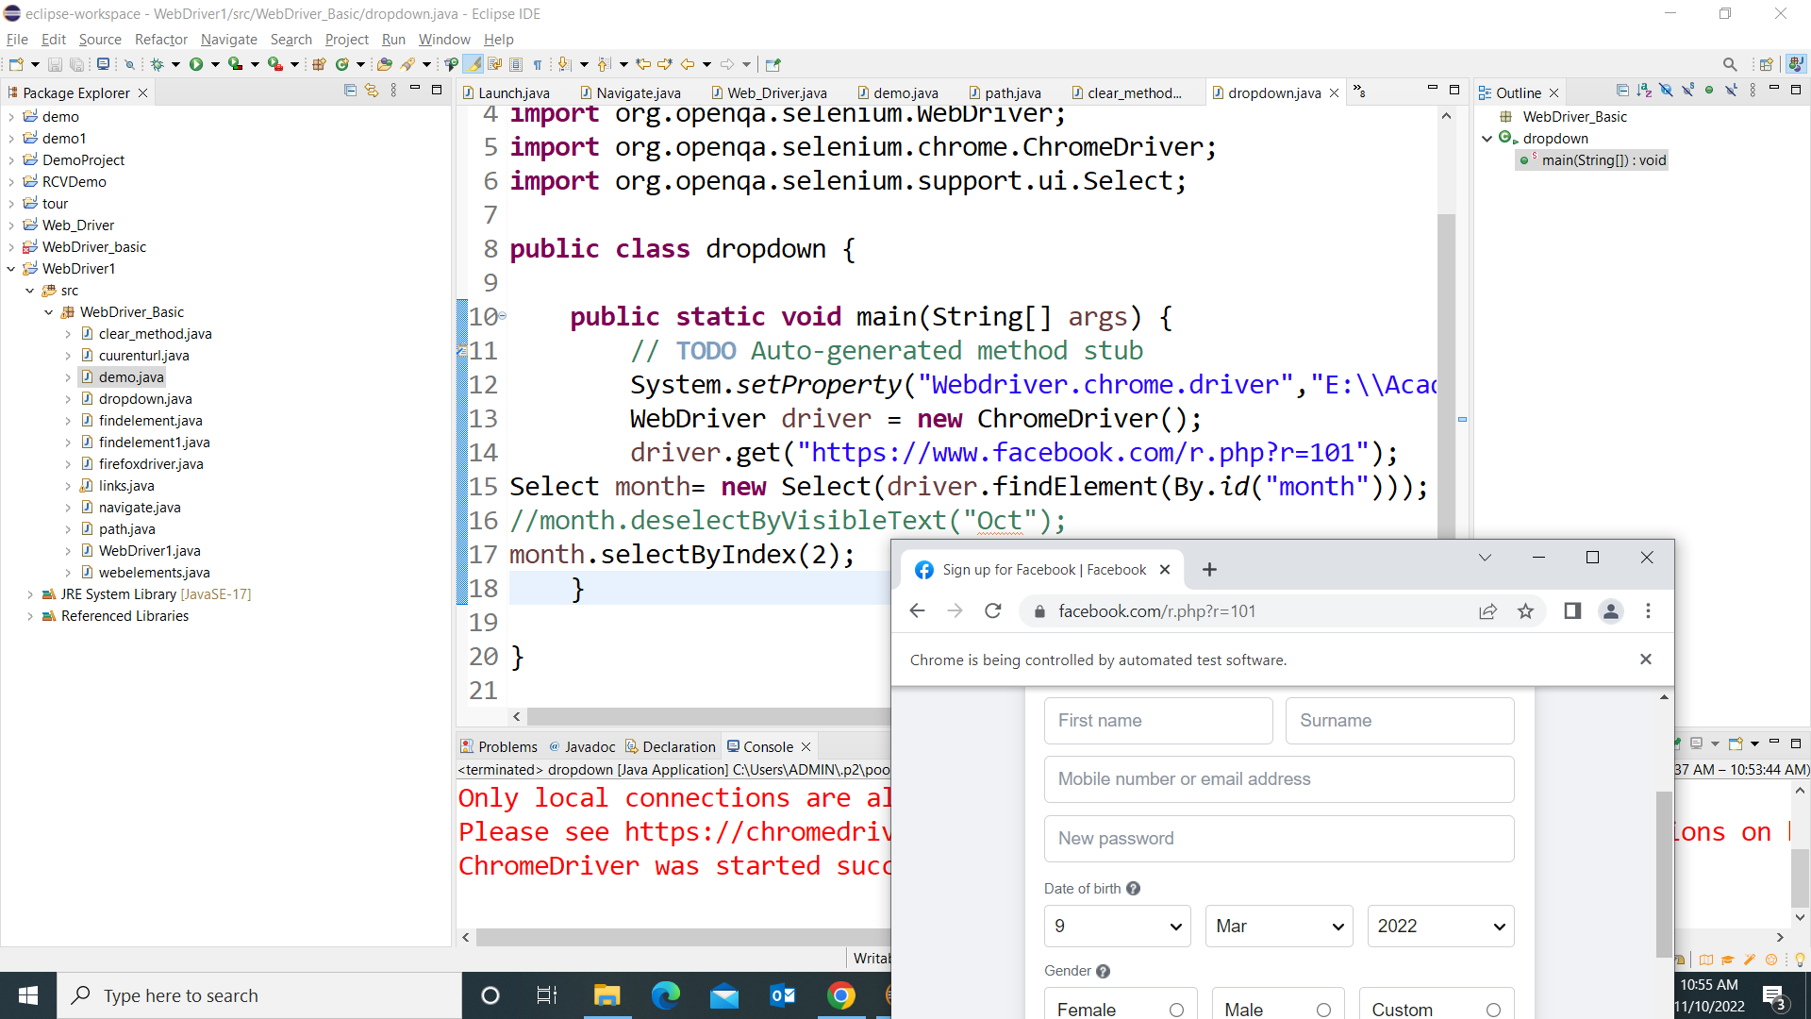

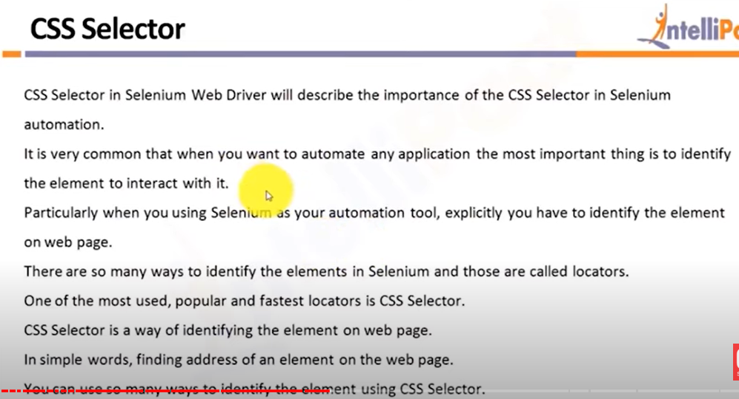

For CSS selector video time 2.44.00 (Self Learning)

**Radio Button (**Radio Button : 2.56.0 onwards )

Radio1.html

<html>

<head>

</head>

<body>

<input type="radio" name="group1" value="India">India<br>

<input type="radio" name="group1" value="China">China<br>

<input type="radio" name="group1" value="Pak">Pak<br>

<hr>

<input type="radio" name="group2" value="Mumbai">Mumbai<br>

<input type="radio" name="group2" value="Delhi">Delhi<br>

<input type="radio" name="group2" value="Pune">Pune<br>

</body>

</html>

Radio1 class file

**package** WebDriver_Basic;

**import** org.openqa.selenium.By;

**import** org.openqa.selenium.WebDriver;

**import** org.openqa.selenium.chrome.ChromeDriver;

**public** **class** radio1 {

**public** **static** **void** main(String[] args) {

// **TODO** Auto-generated method stub

System.*setProperty*("Webdriver.chrome.driver","E:\\Academics\\STQA\\2022\\selenium\\Practical\\Driver\\chromedriver.exe");

WebDriver driver = **new** ChromeDriver();

driver.get("file:///C:/Users/ADMIN/eclipse-workspace/WebDriver1/src/WebDriver_Basic/radio1.html");

//open html file in browser and paste that address here

driver.findElement(By.*xpath*("/html/body/input[3]")).click();

}

}

Output:

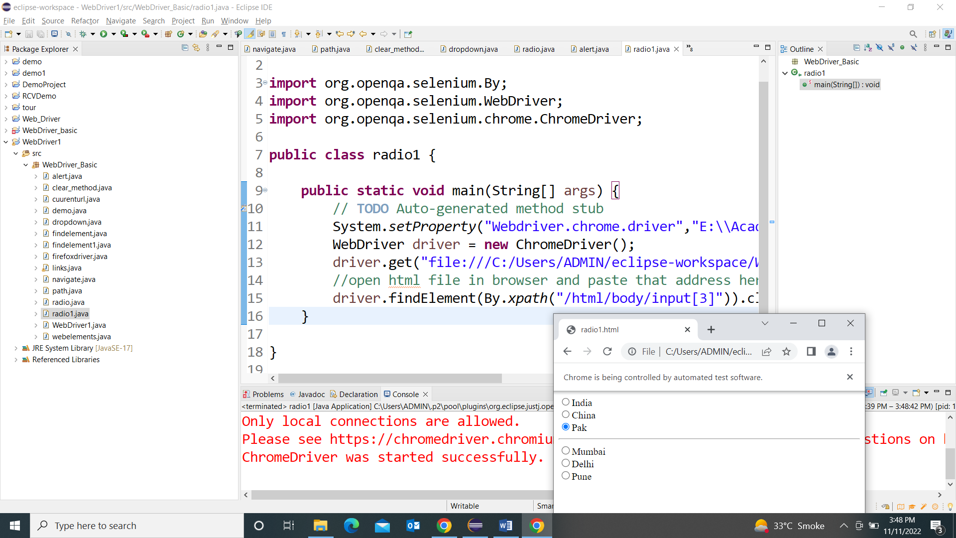

**package** WebDriver_Basic;

**import** java.util.List;

**import** org.openqa.selenium.By;

**import** org.openqa.selenium.WebDriver;

**import** org.openqa.selenium.WebElement;

**import** org.openqa.selenium.chrome.ChromeDriver;

**import** org.openqa.selenium.support.ui.Select;

**public** **class** radio {

**public** **static** **void** main(String[] args) **throws** InterruptedException {

// **TODO** Auto-generated method stub

System.*setProperty*("Webdriver.chrome.driver","E:\\Academics\\STQA\\2022\\selenium\\Practical\\Driver\\chromedriver.exe");

WebDriver driver = **new** ChromeDriver();

driver.get("https://www.facebook.com/r.php?r=101");

Select month= **new** Select(driver.findElement(By.*id*("month")));

month.selectByIndex(2);

List <WebElement> gender =driver.findElements(By.*name*("sex"));

**int** cnt=gender.size();

System.***out***.println(cnt);

//=================================

**for**(**int** i=0; i<cnt; i++)

{

String text = gender.get(i).getText();

System.***out***.println(text);

gender.get(i).click();

Thread.*sleep*(2000);

}

}

}

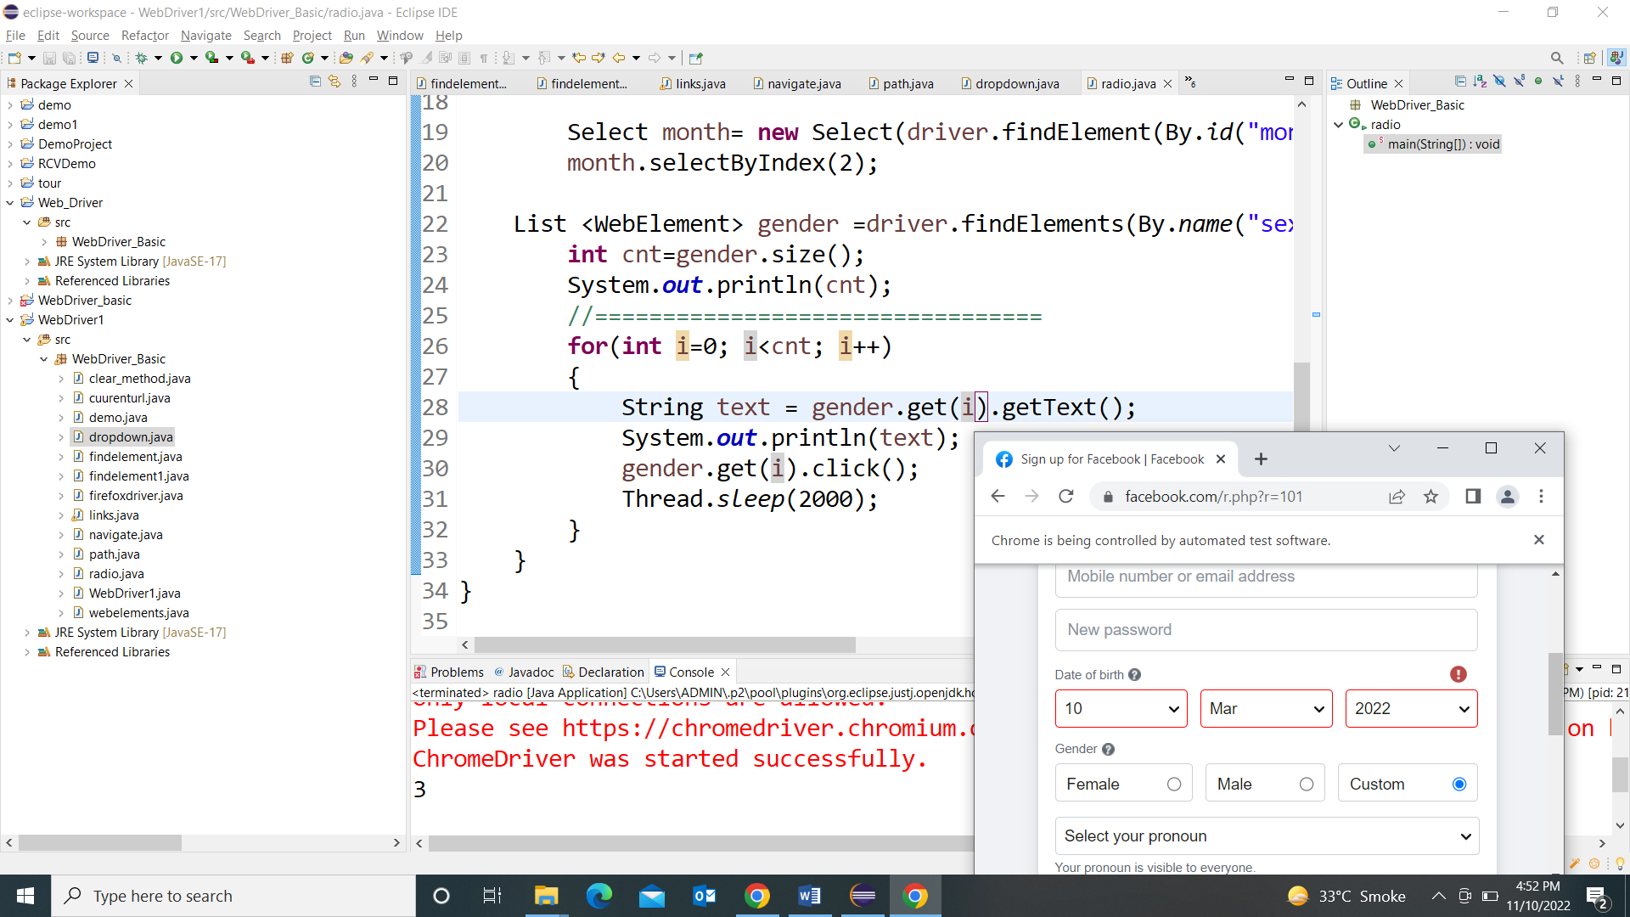

**Web Alerts : 3.07 onwards**

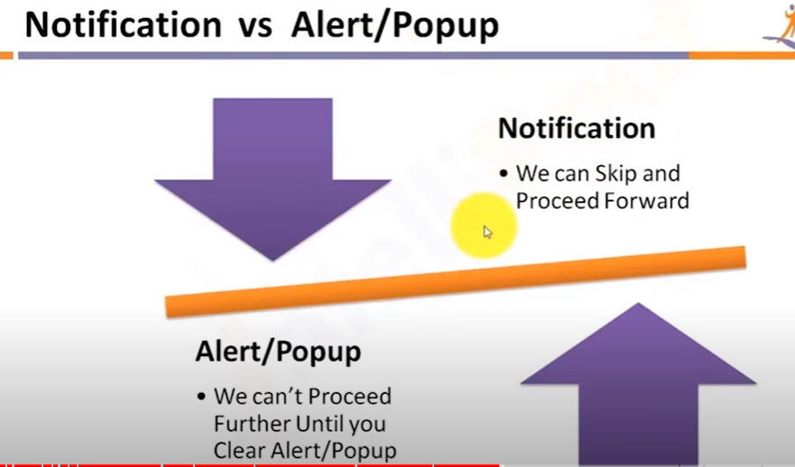

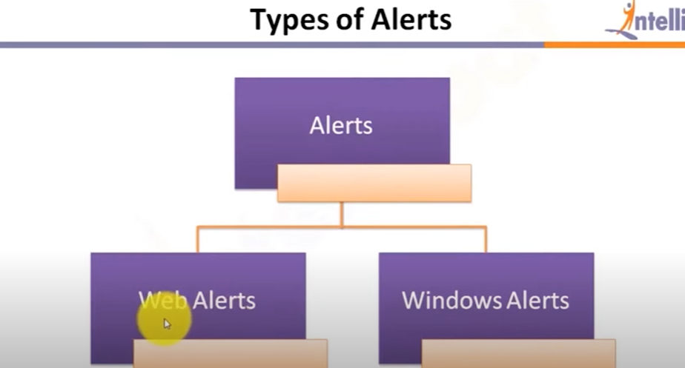

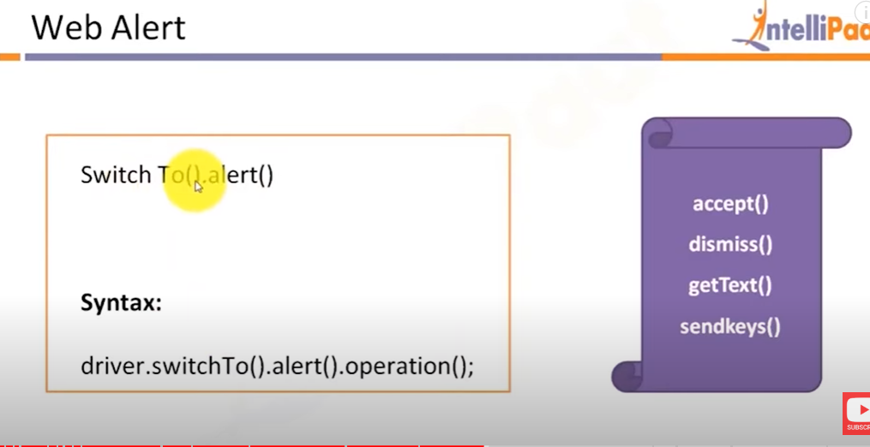

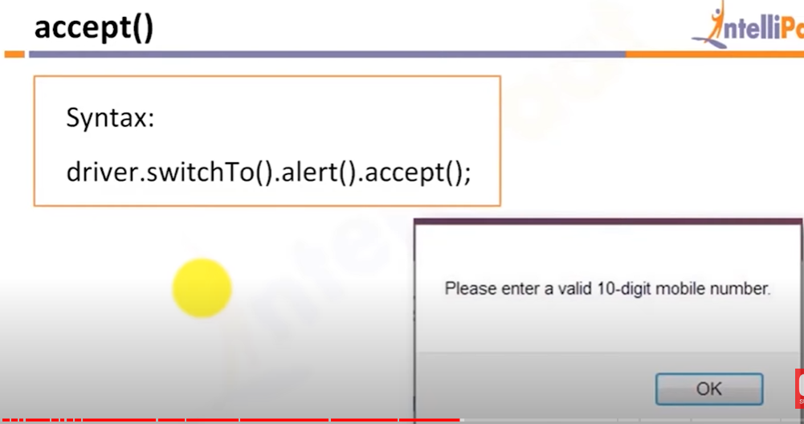

**For alert:**

* ***Void accept()***: This method clicks on the '*OK*' button of the alert box.

driver.switchTo( ).alert( ).accept();

* ***Void dismiss()***: We use this method when the '*Cancel*' button clicks in the alert box.

driver.switchTo( ).alert( ).dismiss();

* ***String getText()***: This method captures the message from the alert box.

driver.switchTo().alert().getText();

* ***Void sendKeys****(String stringToSend)*: This method sends data to the alert box.

driver.switchTo().alert().sendKeys("Text");

Link: <https://demo.guru99.com/test/delete_customer.php>

**package** WebDriver_Basic;

**import** org.openqa.selenium.Alert;

**import** org.openqa.selenium.By;

**import** org.openqa.selenium.WebDriver;

**import** org.openqa.selenium.chrome.ChromeDriver;

**public** **class** alert {

**public** **static** **void** main(String[] args) **throws** InterruptedException {

// **TODO** Auto-generated method stub

System.*setProperty*("Webdriver.chrome.driver","E:\\Academics\\STQA\\2022\\selenium\\Practical\\Driver\\chromedriver.exe");

WebDriver driver = **new** ChromeDriver();

driver.get("https://demo.guru99.com/test/delete_customer.php");

driver.findElement(By.*name*("cusid")).sendKeys("30");

driver.findElement(By.*name*("submit")).click();

// Switching to Alert

Alert alt = driver.switchTo().alert();

// Capturing alert message.

String alertMessage= driver.switchTo().alert().getText();

// Displaying alert message

System.***out***.println(alertMessage);

Thread.*sleep*(5000);

// Accepting alert i.e. Ok click

alt.accept();

}

}

Output: When you execute the above code, it launches the site. Try to delete Customer ID by handling confirmation alert that displays on the screen, and thereby deleting customer id from the application.

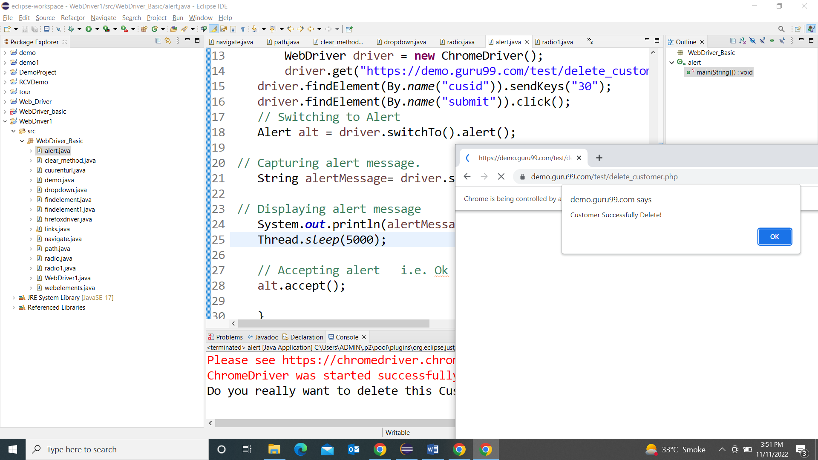

**Frame**

# How to Handle iFrames in Selenium Webdriver: switchTo()

## iFrame in Selenium Webdriver

**iFrame in Selenium Webdriver** is a web page or an inline frame which is embedded in another web page or an HTML document embedded inside another HTML document. The iframe is often used to add content from other sources like an advertisement into a web page. The iframe is defined with the <**iframe**> tag.

## How to identify the iframe:

We cannot detect the frames by just seeing the page or by inspecting Firebug.

* Right click on the page and click ‘View Page Source’ and Search with the ‘iframe’, if you can find any tag name with the ‘iframe’ then it is meaning to say the page consisting an iframe.
* We can even identify total number of iframes by using below snippet.
* Int size = driver.findElements(By.tagName("iframe")).size();

## How to switch over the elements in iframes using Web Driver commands:

Basically, we can switch over the elements and handle frames in Selenium using 3 ways.

* **By Index**
* **By Name or Id**
* **By Web Element**

**Switch to the frame by index:**

Index is one of the attributes for frame handling in Selenium through which we can switch to it.

Index of the iframe starts with ‘0’.

Suppose if there are 100 frames in page, we can switch to frame in Selenium by using index.

* driver.switchTo().frame(0);
* driver.switchTo().frame(1);

**Switch to the frame by Name or ID:**

Name and ID are attributes for handling frames in Selenium through which we can switch to the iframe.

* driver.switchTo().frame(“iframe1”);
* driver.switchTo().frame(“id of the element”);

**Example of Switching to iframe through ID:**

Let’s take an example to switch frame in Selenium displayed in the below image. Our requirement is to click the iframe.

We can access this iframe through this below URL: http://demo.guru99.com/test/guru99home/

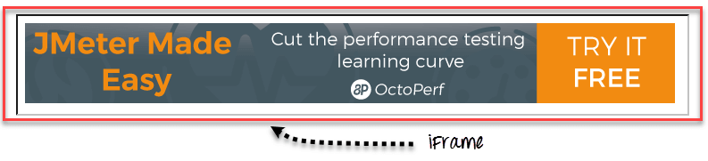

It is impossible to click iframe directly through[XPath](https://www.guru99.com/xpath-selenium.html)since it is an iframe. First we have to switch to the frame and then we can click using xpath.

**Step 1)**

WebDriver driver = new FirefoxDriver();

driver.get("http://demo.guru99.com/test/guru99home/");

driver.manage().window().maximize();

* We initialise the Firefox driver.
* Navigate to the “guru99” site which consist the iframe.
* Maximized the window.

**Step 2)**

driver.switchTo().frame("a077aa5e");

* In this step we need to find out the id of the iframe by inspecting through Firebug.
* Then switch to the iframe through ID.

**Step 3)**

driver.findElement(By.xpath("html/body/a/img")).click();

* Here we need to find out the xpath of the element to be clicked.
* Click the element using web driver command shown above.

Here is the complete code:

**package** WebDriver_Basic;

**import** org.openqa.selenium.By;

**import** org.openqa.selenium.WebDriver;

**import** org.openqa.selenium.chrome.ChromeDriver;

**public** **class** frame {

**public** **static** **void** main(String[] args) {

// **TODO** Auto-generated method stub

System.*setProperty*("Webdriver.chrome.driver","E:\\Academics\\STQA\\2022\\selenium\\Practical\\Driver\\chromedriver.exe");

WebDriver driver = **new** ChromeDriver();

driver.get("http://demo.guru99.com/test/guru99home/");

// navigates to the page consisting an iframe

driver.manage().window().maximize();

driver.switchTo().frame("a077aa5e");

System.***out***.println("We are switch to the iframe");

driver.findElement(By.*xpath*("html/body/a/img")).click();

//Clicks the iframe

System.***out***.println("*We are done*");

}

}

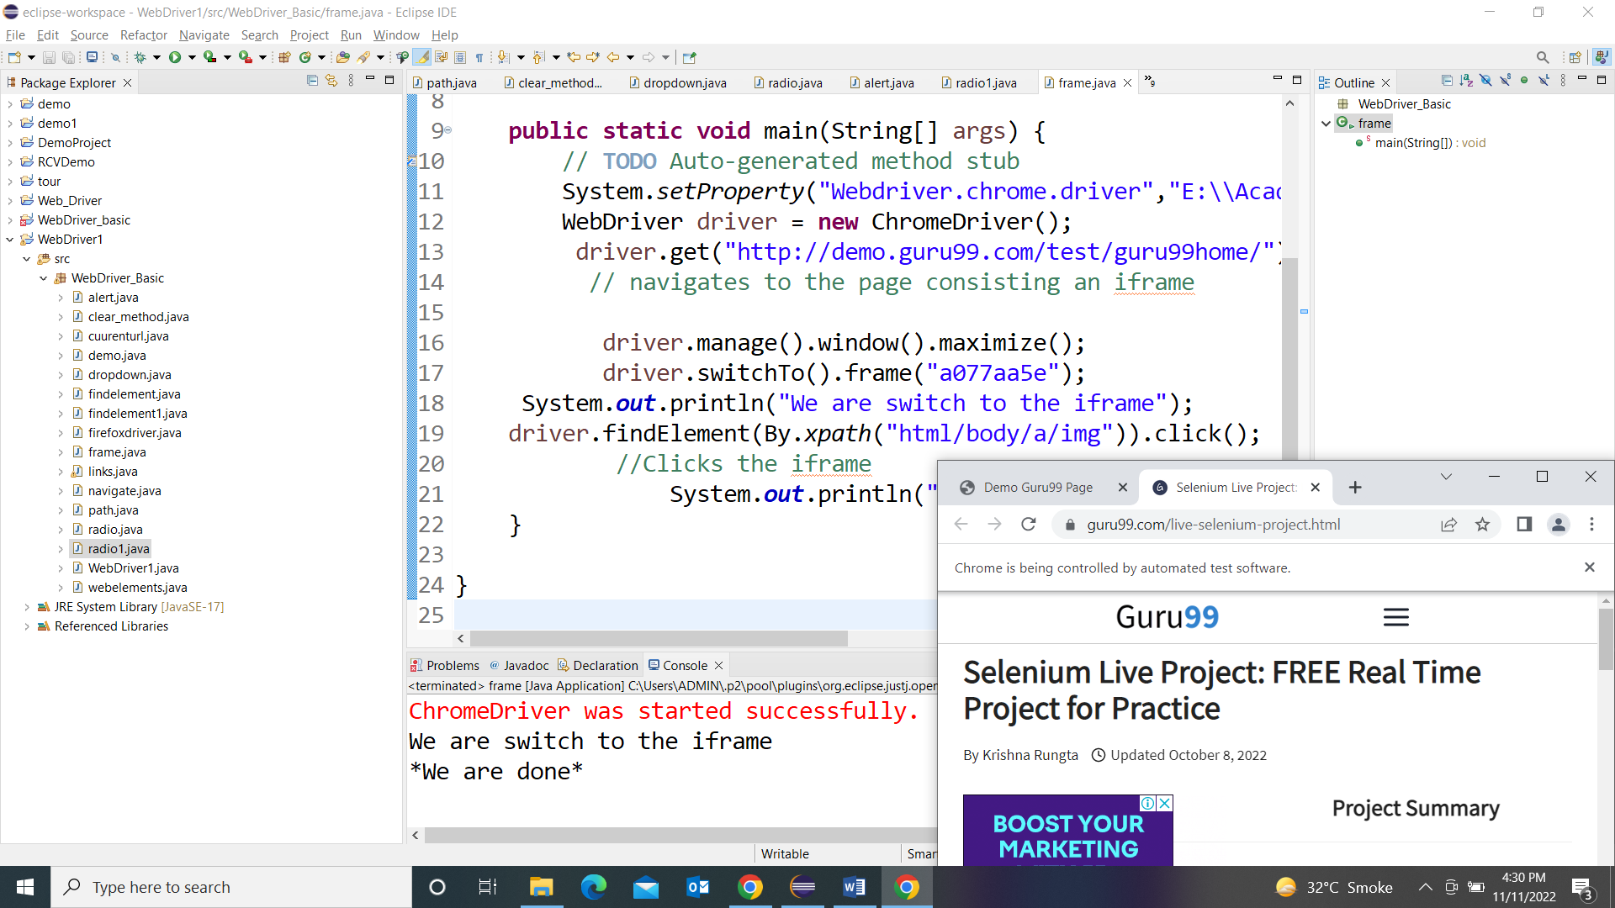

**TestNg**

**TestNG is an advance framework** designed in a way to leverage the benefits by both the developers and testers.

**TestNG** is an automation testing framework in which NG stands for “Next Generation”. TestNG is inspired by [JUnit](https://www.guru99.com/junit-tutorial.html) which uses the annotations (@). TestNG overcomes the disadvantages of JUnit and is designed to make [end-to-end testing](https://www.guru99.com/end-to-end-testing.html) easy.

Using TestNG, you can generate a proper report, and you can easily come to know how many test cases are passed, failed, and skipped. You can execute the failed test cases separately.

For example:

* Suppose, you have five test cases, one method is written for each test case (Assume that the program is written using the main method without using testNG). When you run this program first, three methods are executed successfully, and the fourth method is failed. Then correct the errors present in the fourth method, now you want to run only fourth method because first three methods are anyway executed successfully. This is not possible without using TestNG.
* The TestNG in Selenium provides an option, i.e., testng-failed.xml file in test-output folder. If you want to run only failed test cases means you run this XML file. It will execute only failed test cases.

**Installation**

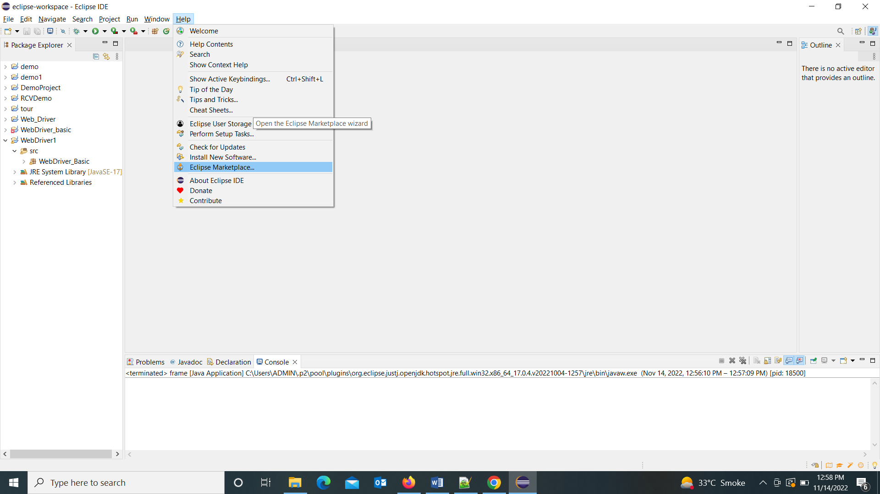

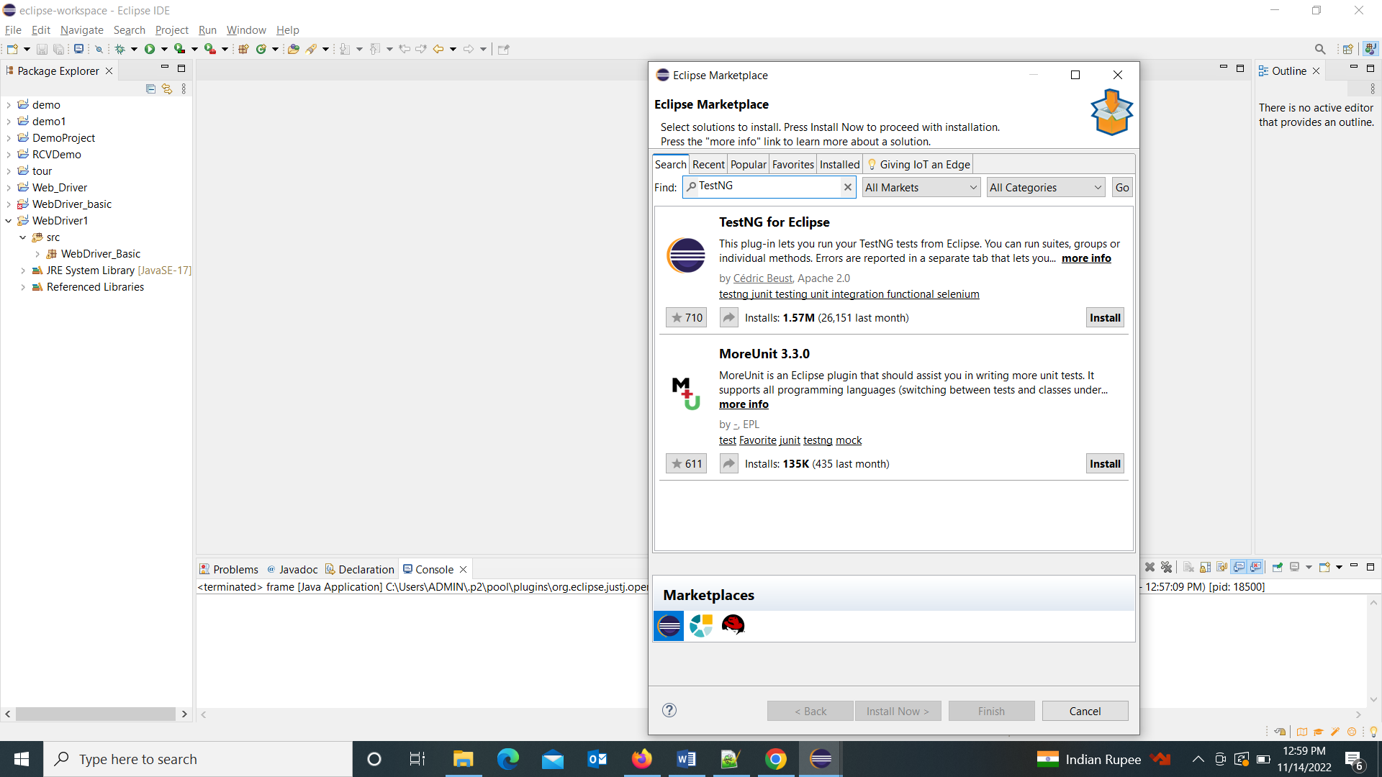

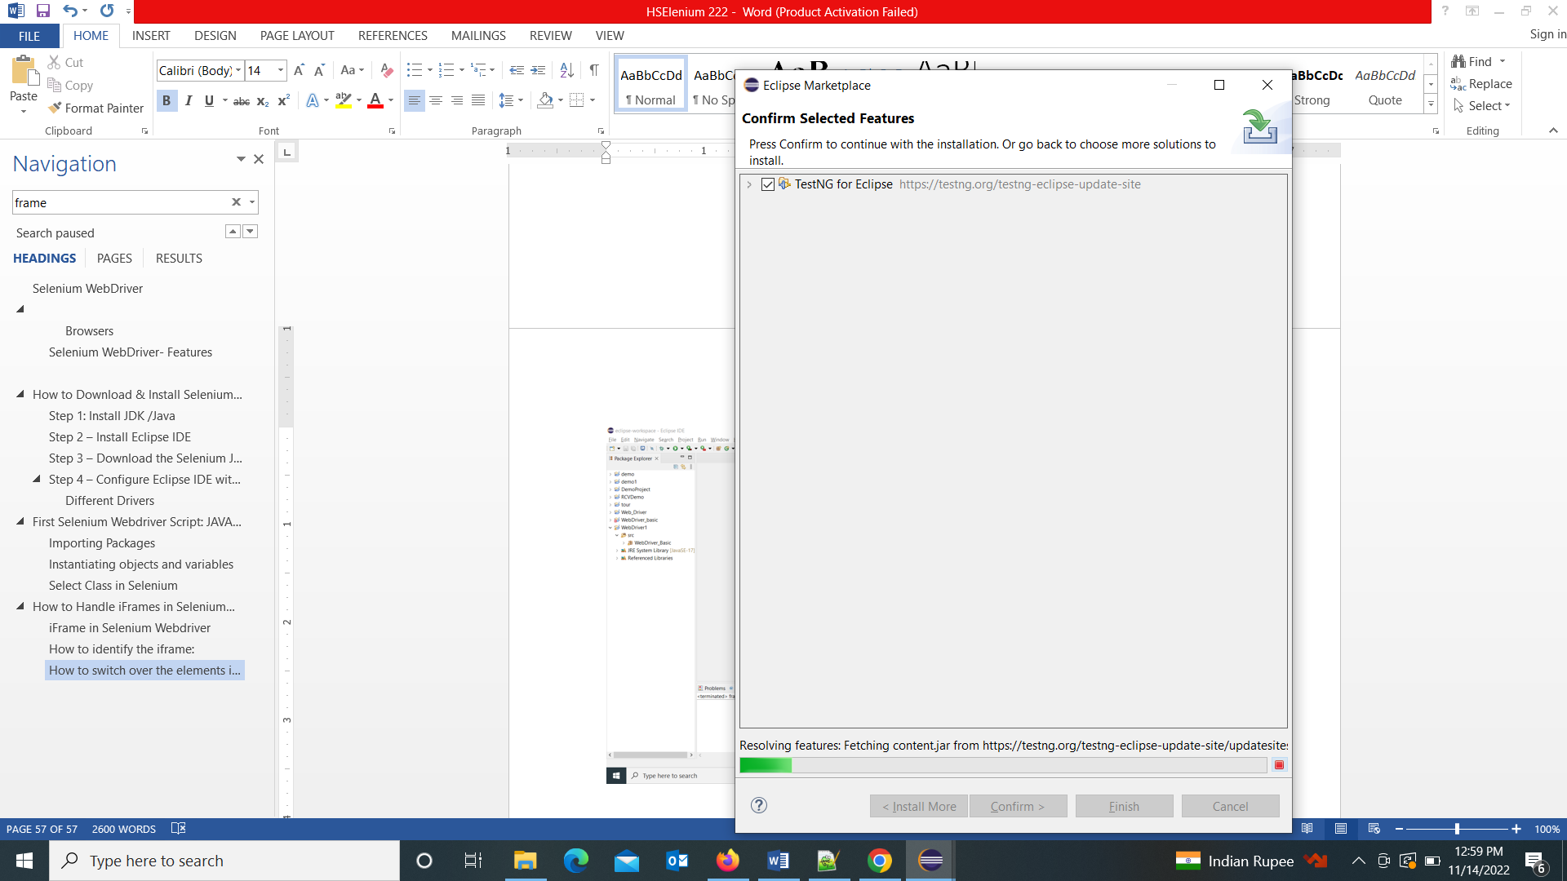

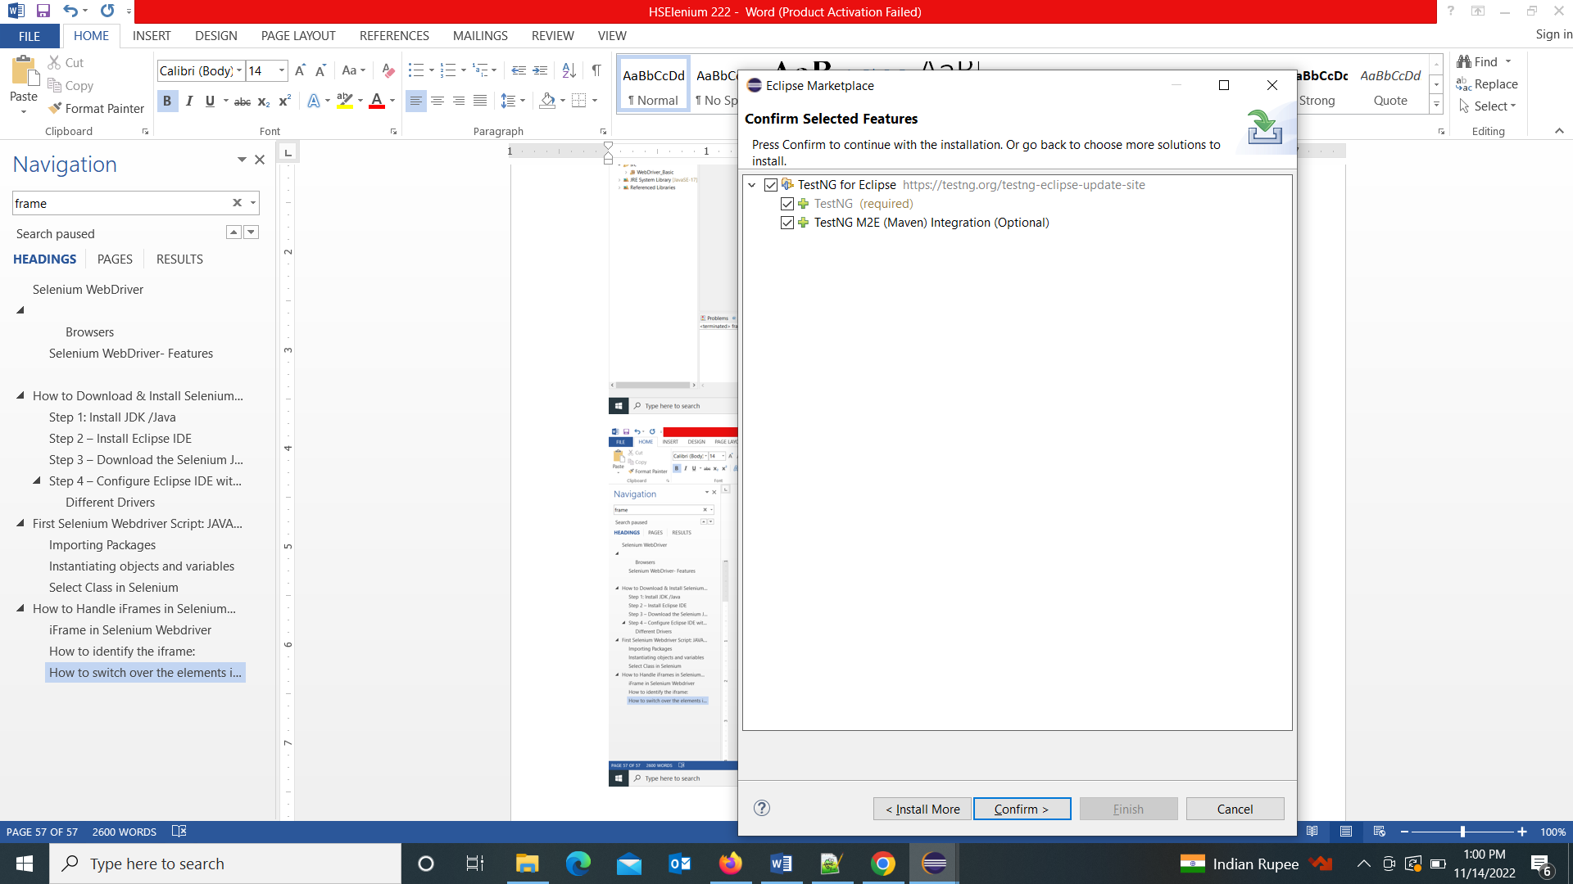

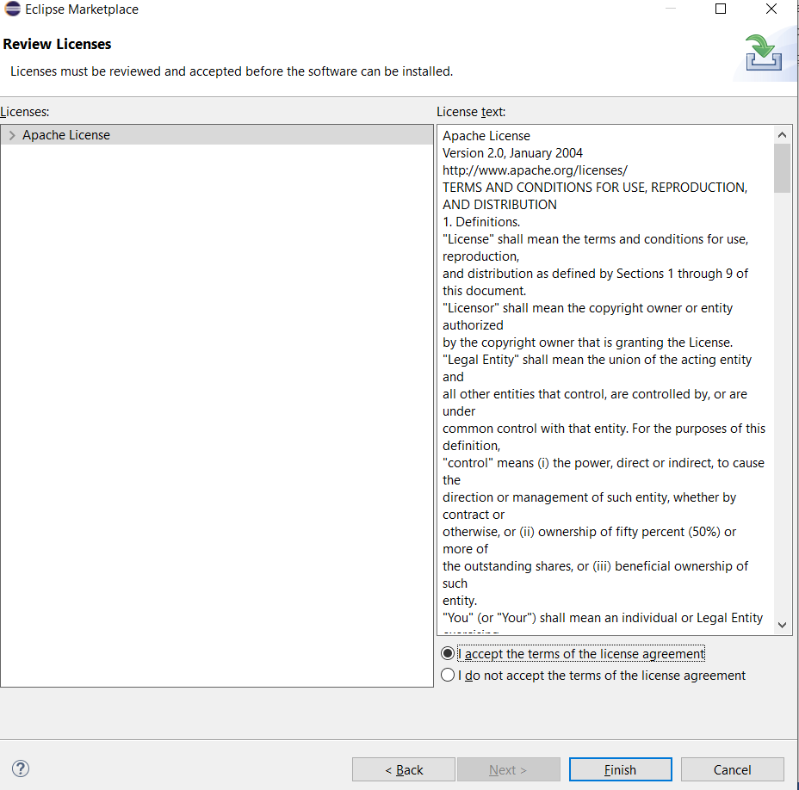

**Step 5)** After accept the licence agreement,

wait for installation.

ignore security warning if occurs

If you encounter a Security warning, just click “Install Anyway”.

**Or select all trust issues**

Finish the installation and restart your system

Wait for the TestNG install in Eclipse to finish. When Eclipse prompts you for a restart, click “Restart now.”

Verify if the installation is done properly

After the restart, verify if TestNG for Eclipse was indeed successfully installed. Click Window > Show View > Other.

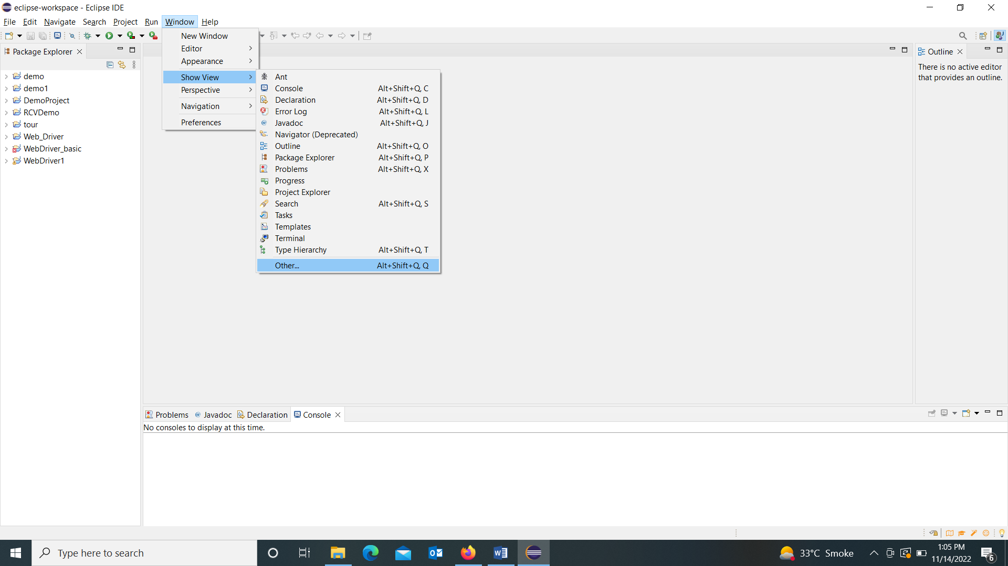

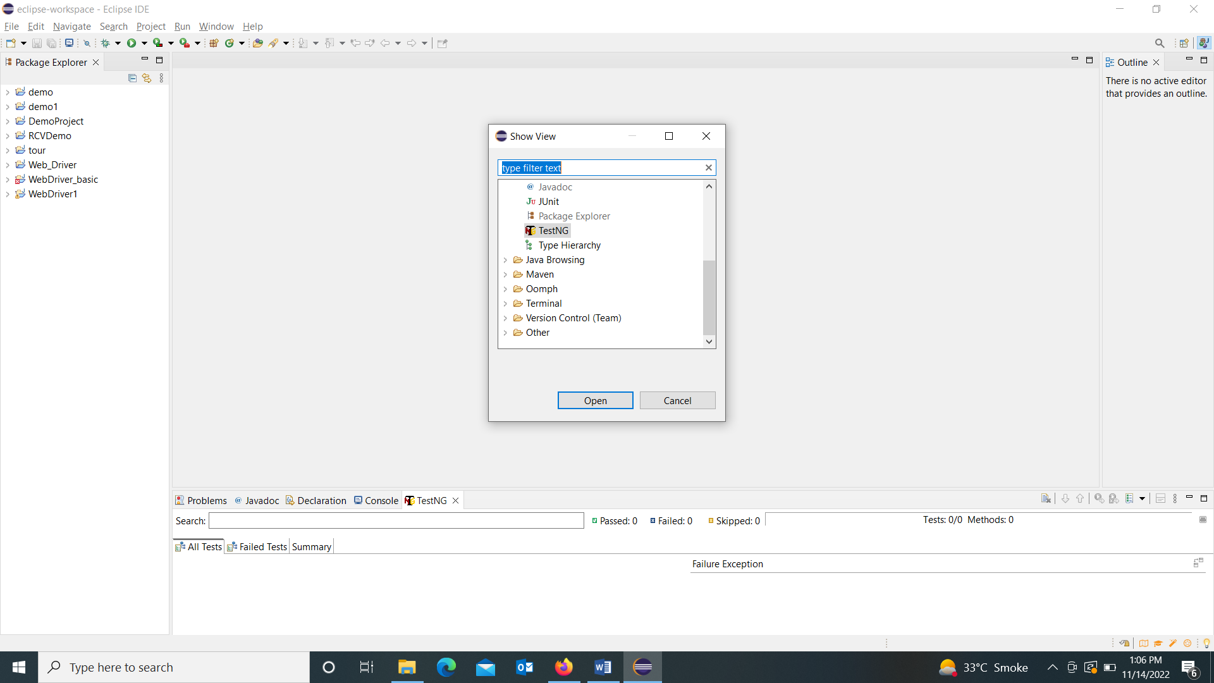

**Click on open and that’s it..Now see the changes in console..**

**It has opened Test NG Terminal also**

**Test NG Installation steps :**

[**https://www.guru99.com/install-testng-in-eclipse.html**](https://www.guru99.com/install-testng-in-eclipse.html)

**If this does not work try this :**

1. Help--->Install new software-->already installed --->TestNG (All)---> Uninstall ---> restart now (Eclipse will restart)
2. After restart again Help-->Install new software --> Clicks on 'Add' ---> Name TESTNG URL - <https://testng.org/testng-eclipse-update-site/7.4.0/> ---> Ok
3. After install restart now Eclipse
4. You got the TestNG

## **Create Test Case Using TestNG Annotations**

### Setting up a new TestNG Project

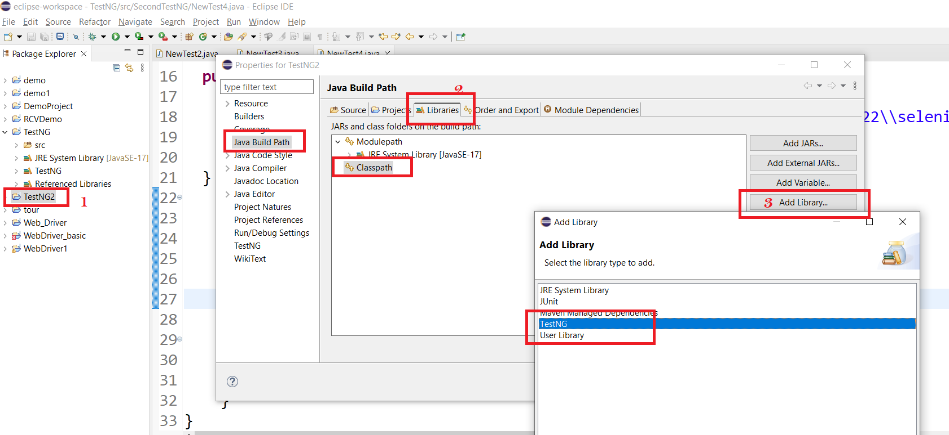

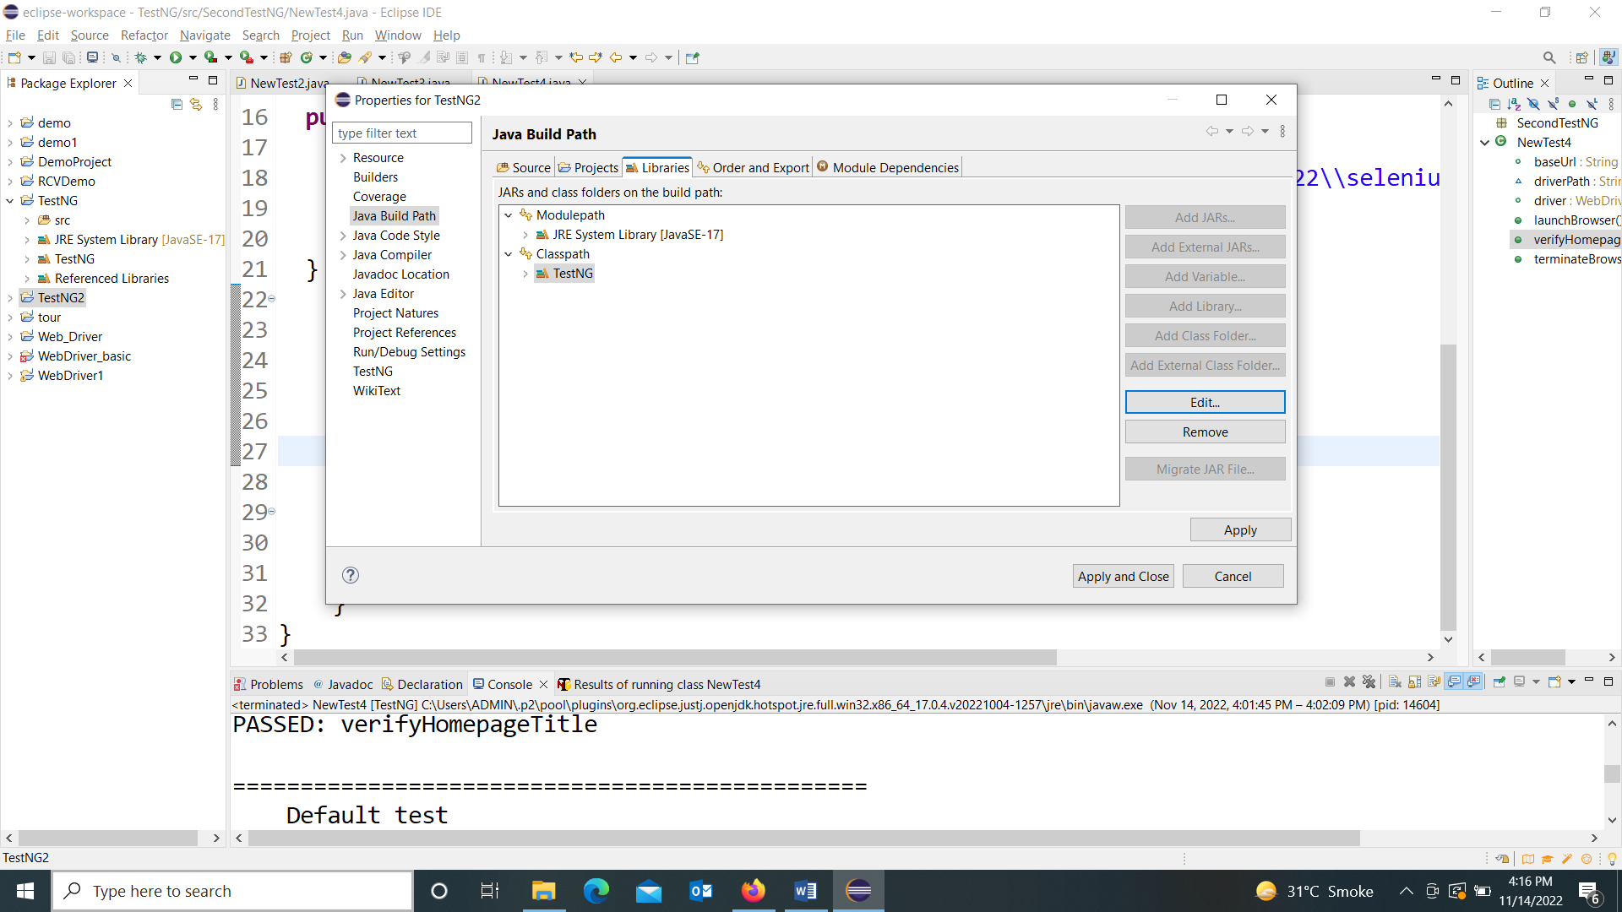

You should notice that TestNG is included on the Libraries list.

We will now add the JAR files that contain the Selenium API.

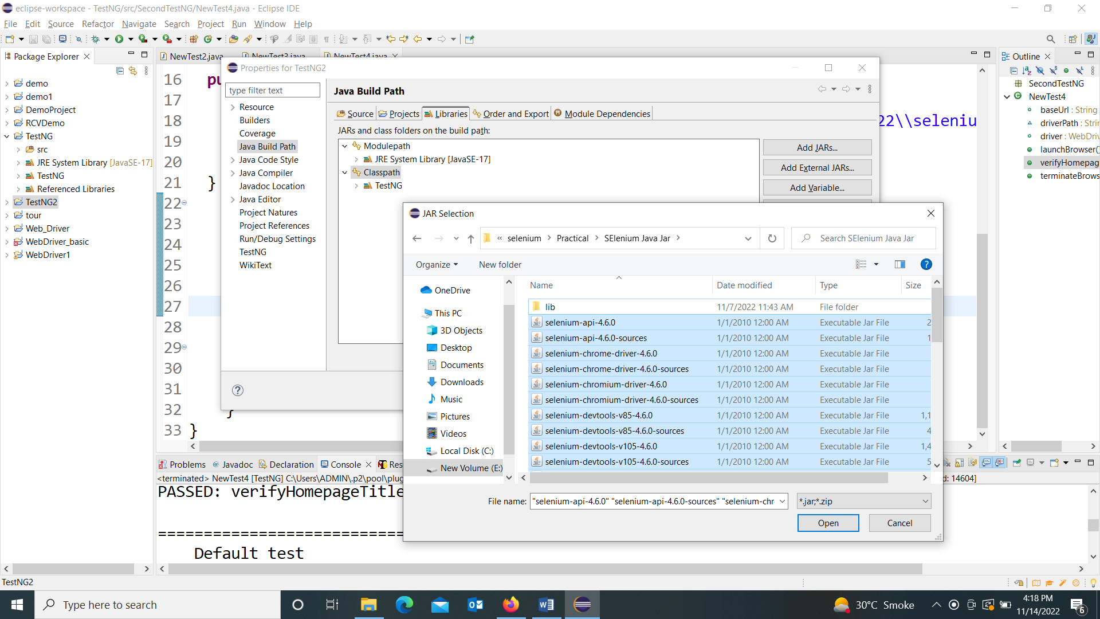

Now at left side you will see this TEstNG2 project has been created

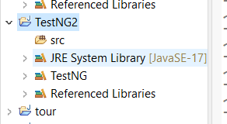

After adding all Jar files now we wil create first Test NG program

Now that we are done setting up our project in this TestNG tutorial, let us create a new TestNG file.

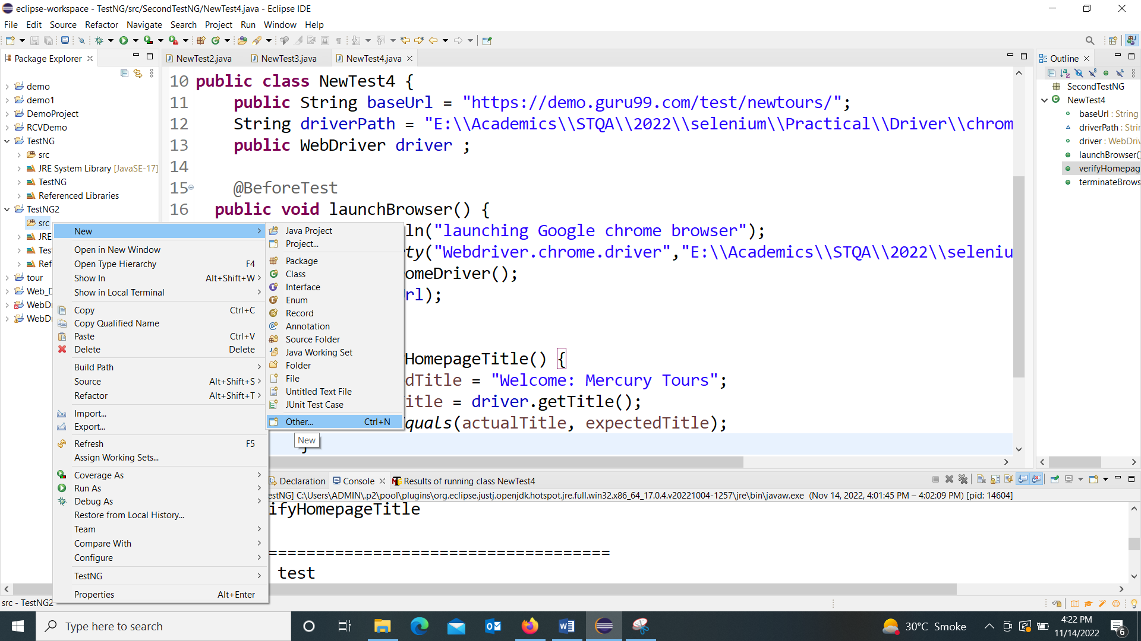

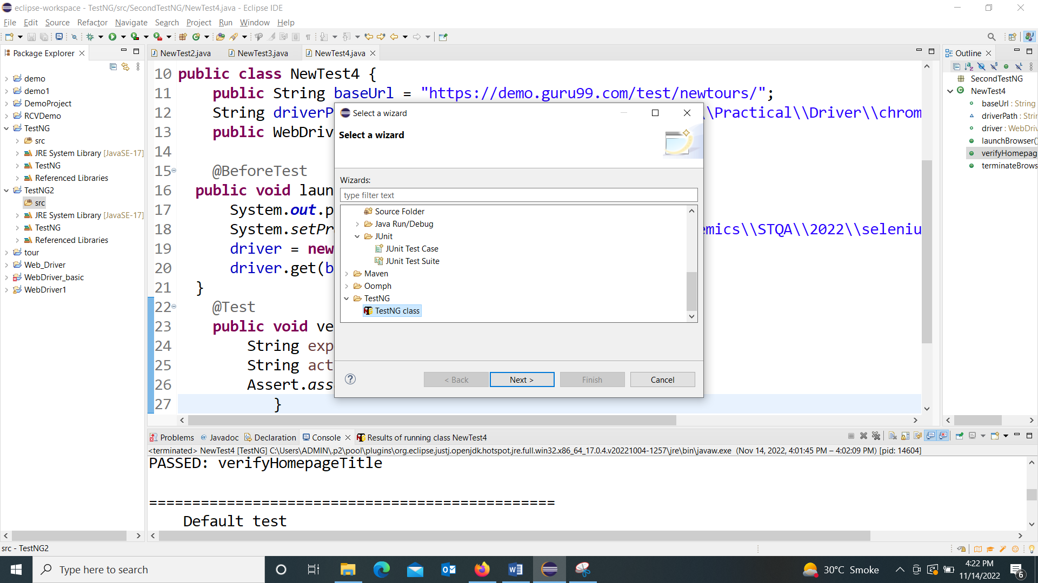

Double Click on TestNG class

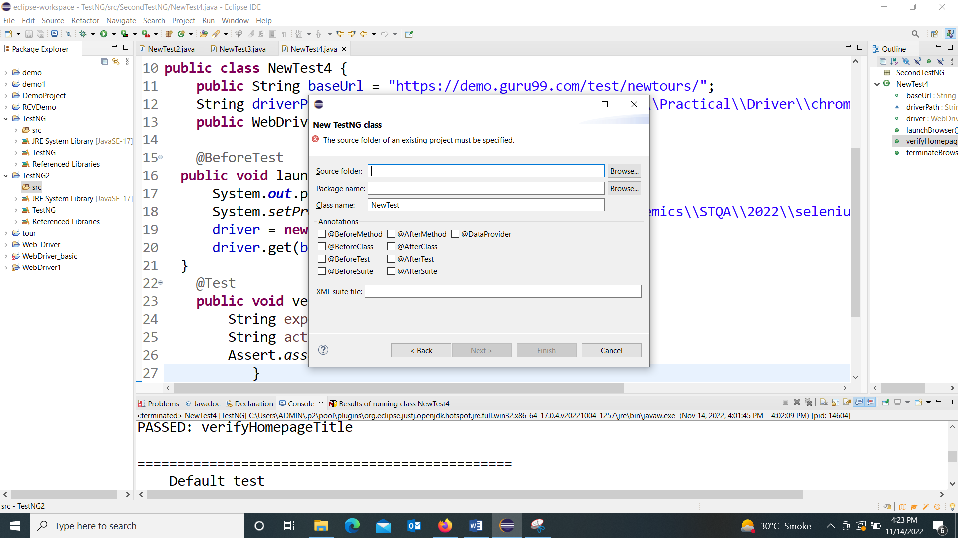

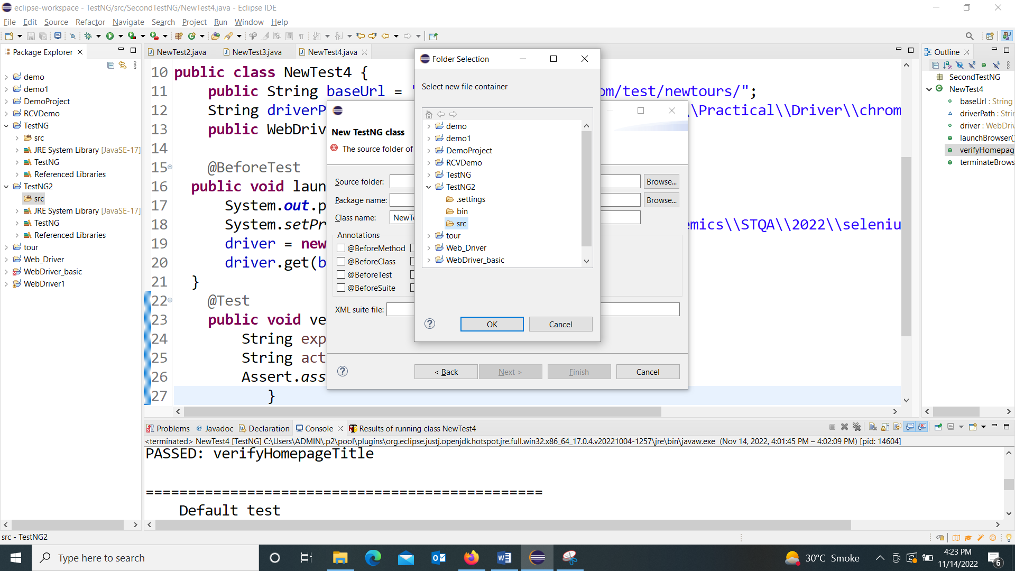

Here browse foe source folder i.e. TestNG2:

Then

Give any package name : demo

And then class name: newTest1

And click on Finish

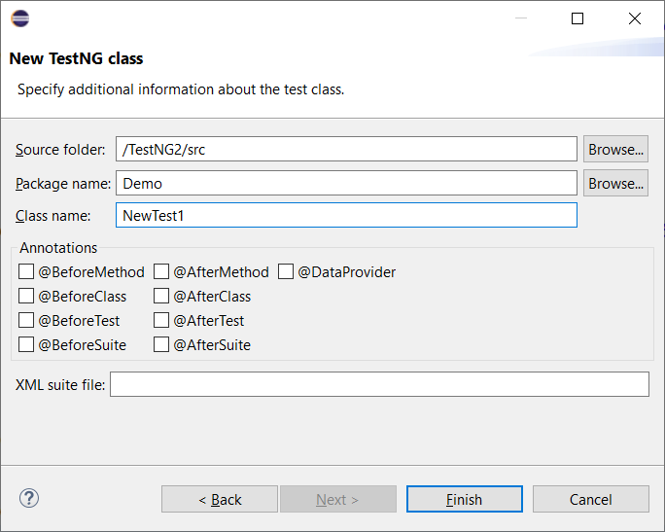

It will open

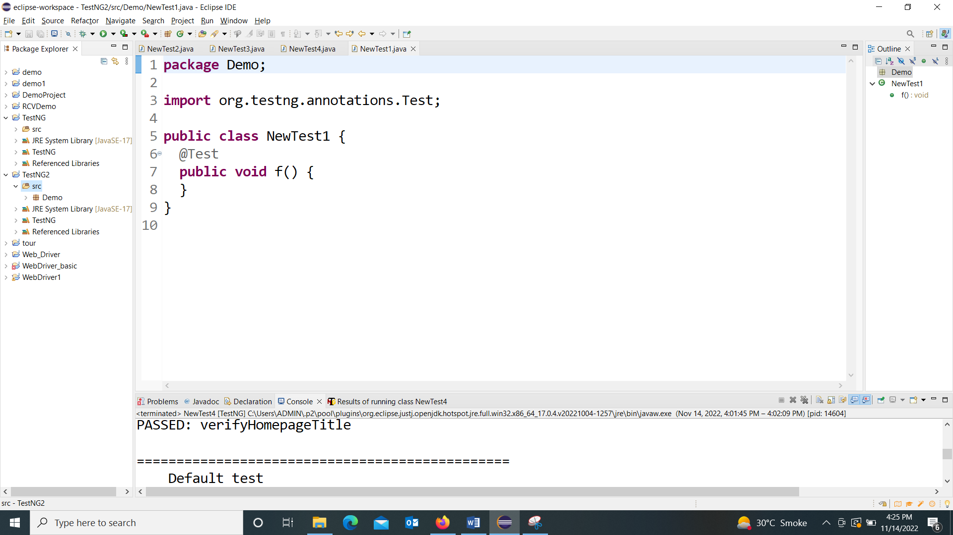

One class file in source file

Now you can write code

**Programme**

**package** SecondTestNG;

**import** org.openqa.selenium.By;

**import** org.openqa.selenium.Keys;

**import** org.openqa.selenium.WebDriver;

**import** org.openqa.selenium.chrome.ChromeDriver;

**import** org.testng.annotations.Test;

**public** **class** NewTest2 {

**public** String baseUrl = "https://www.google.com/";

String driverPath = "E:\\Academics\\STQA\\2022\\selenium\\Practical\\Driver\\chromedriver.exe";

**public** WebDriver driver ;

@Test

**public** **void** f() **throws** InterruptedException {

System.***out***.println("launching chrome browser");

System.*setProperty*("Webdriver.chrome.driver", driverPath);

driver = **new** ChromeDriver();

driver.get(baseUrl);

driver.findElement(By.*name*("q")).sendKeys("DES's NMITD",Keys.***ENTER***);

Thread.*sleep*(2000);

}

}

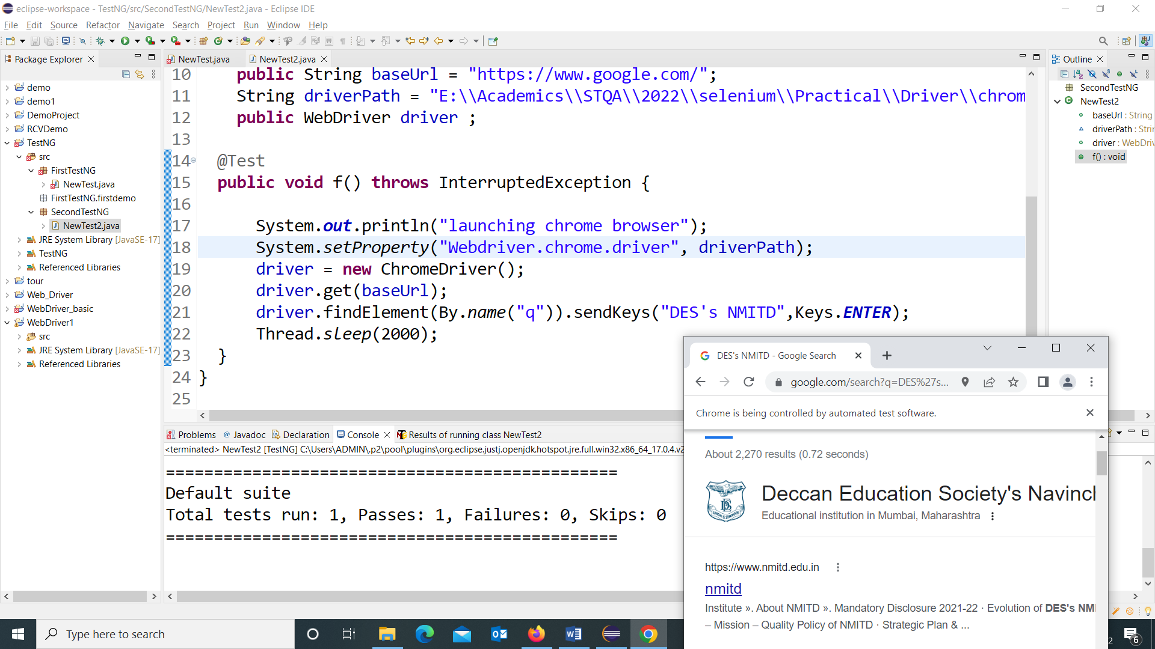

**Programm 2**

**To Create another program in same package**

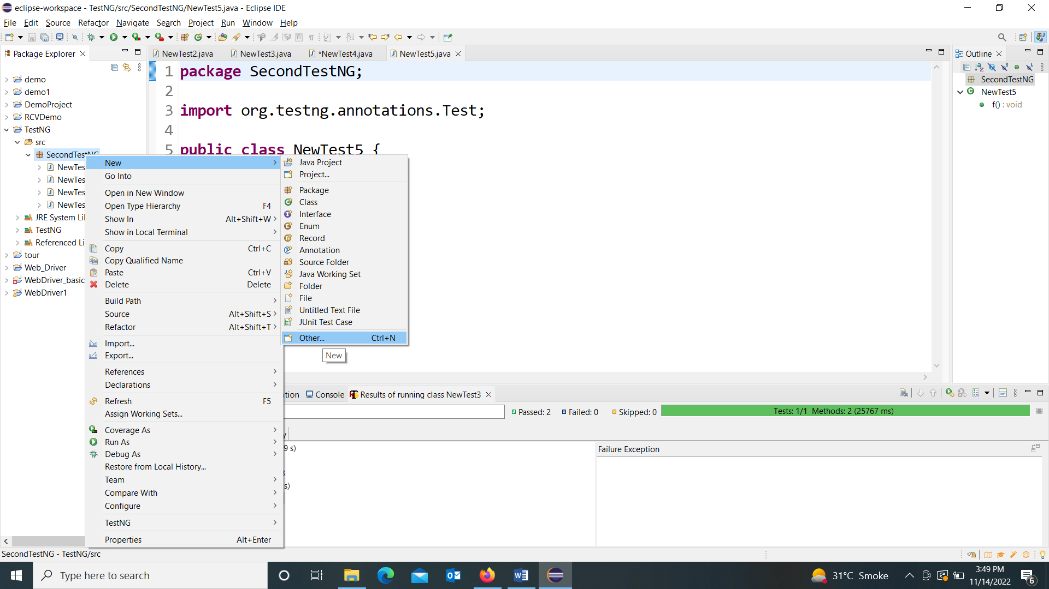

**Click on SRC🡺TestNG Folder(any package name)🡺New 🡺 Other🡺 Double Click on TestNG and then type class anme 🡺 here it is NewTest6🡺 and the finish with/without any annotation**

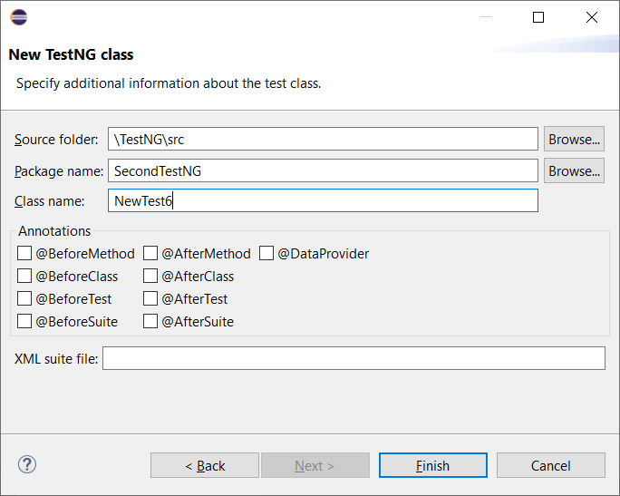

**It will create new file with class name and @test annotation and with default f() Method**

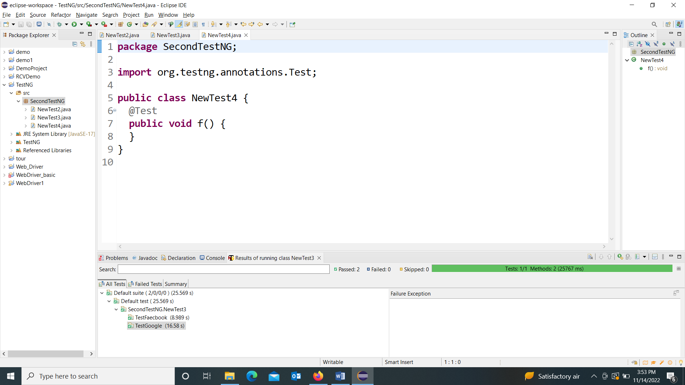

**Multiple Test cases**

**package** SecondTestNG;

**import** org.openqa.selenium.By;

**import** org.openqa.selenium.Keys;

**import** org.openqa.selenium.WebDriver;

**import** org.openqa.selenium.chrome.ChromeDriver;

**import** org.testng.annotations.Test;

**public** **class** NewTest3 {

@Test

**public** **void** TestGoogle() **throws** InterruptedException {

System.*setProperty*("Webdriver.chrome.driver","E:\\Academics\\STQA\\2022\\selenium\\Practical\\Driver\\chromedriver.exe");

WebDriver driver = **new** ChromeDriver();

driver.get("https://www.google.com/");

driver.findElement(By.*name*("q")).sendKeys("DES's NMITD",Keys.***ENTER***);

Thread.*sleep*(2000);

}

@Test

**public** **void** TestFaecbook() **throws** InterruptedException {

System.*setProperty*("Webdriver.chrome.driver","E:\\Academics\\STQA\\2022\\selenium\\Practical\\Driver\\chromedriver.exe");

WebDriver driver = **new** ChromeDriver();

driver.get("https://www.facebook.com/");

driver.findElement(By.*name*("email")).sendKeys("DES's NMITD",Keys.***ENTER***);

Thread.*sleep*(2000);

}

}

**Output:**

**It will open two browsers to test the 2 test cases…first🡺facebook and second🡺google**

**Because TestNG runs test methods alphabetically**

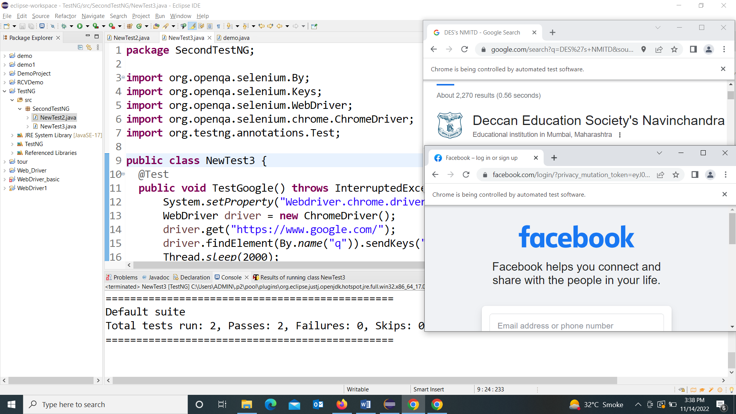

**Test Annotation**

## Annotations in TestNG

Annotations were formally added to the Java language in JDK 5 and TestNG made the choice to use annotations to annotate test classes. Following are some of the benefits of using annotations. More about TestNG can be found [**here**](https://www.tutorialspoint.com/testng/index.htm)

* TestNG identifies the methods it is interested in by looking up annotations. Hence, method names are not restricted to any pattern or format.
* We can pass additional parameters to annotations.
* Annotations are strongly typed, so the compiler will flag any mistakes right away.
* Test classes no longer need to extend anything (such as TestCase, for JUnit 3).

|  |  |
| --- | --- |
| **Sr.No.** | **Annotation & Description** |
| 1 | **@BeforeSuite**  The annotated method will be run only once before all the tests in this suite have run. |
| 2 | **@AfterSuite**  The annotated method will be run only once after all the tests in this suite have run. |
| 3 | **@BeforeClass**  The annotated method will be run only once before the first test method in the current class is invoked. |
| 4 | **@AfterClass**  The annotated method will be run only once after all the test methods in the current class have run. |
| 5 | **@BeforeTest**  The annotated method will be run before any test method belonging to the classes inside the <test> tag is run. |
| 6 | **@AfterTest**  The annotated method will be run after all the test methods belonging to the classes inside the <test> tag have run. |
| 7 | **@BeforeGroups**  The list of groups that this configuration method will run before. This method is guaranteed to run shortly before the first test method that belongs to any of these groups is invoked. |
| 8 | **@AfterGroups**  The list of groups that this configuration method will run after. This method is guaranteed to run shortly after the last test method that belongs to any of these groups is invoked. |
| 9 | **@BeforeMethod**  The annotated method will be run before each test method. |
| 10 | **@AfterMethod**  The annotated method will be run after each test method. |
| 11 | **@DataProvider**  Marks a method as supplying data for a test method. The annotated method must return an Object[ ][ ] where each Object[ ] can be assigned the parameter list of the test method. The @Test method that wants to receive data from this DataProvider needs to use a dataProvider name equals to the name of this annotation. |
| 12 | **@Factory**  Marks a method as a factory that returns objects that will be used by TestNG as Test classes. The method must return Object[ ]. |
| 13 | **@Listeners**  Defines listeners on a test class. |
| 14 | **@Parameters**  Describes how to pass parameters to a @Test method. |
| 15 | **@Test**  Marks a class or a method as part of the test. |

**Programme**

**package** SecondTestNG;

**import** org.openqa.selenium.WebDriver;

**import** org.openqa.selenium.chrome.ChromeDriver;

**import** org.testng.Assert;

**import** org.testng.annotations.AfterTest;

**import** org.testng.annotations.BeforeTest;

**import** org.testng.annotations.Test;

**public** **class** NewTest4 {

**public** String baseUrl = "https://demo.guru99.com/test/newtours/";

String driverPath = "E:\\Academics\\STQA\\2022\\selenium\\Practical\\Driver\\chromedriver.exe";

**public** WebDriver driver ;

@BeforeTest

**public** **void** launchBrowser() {

System.***out***.println("launching Google chrome browser");

System.*setProperty*("Webdriver.chrome.driver","E:\\Academics\\STQA\\2022\\selenium\\Practical\\Driver\\chromedriver.exe");

driver = **new** ChromeDriver();

driver.get(baseUrl);

}

@Test

**public** **void** verifyHomepageTitle() {

String expectedTitle = "Welcome: Mercury Tours";

String actualTitle = driver.getTitle();

Assert.*assertEquals*(actualTitle, expectedTitle);

}

@AfterTest

**public** **void** terminateBrowser(){

driver.close();

}

}

**Output**

**THis program will open the browser with demotour web page… check the title and then terminate it.**

